Diamond Attention Network: A Professional Architecture for Parameter-Efficient Image Classification
M. Rajamanogaran¹, S. Baghavathi Priya^{2,*}, Krithikha Sanju S³, Chandra Prakash Palani⁴, Harsha Sankara Narayanan⁵, Bollimuntha Kavya Sai⁶
^{1,2,4,5,6} Department of Computer Science and Engineering, School of Computing, Amrita Vishwa Vidyapeetham, Chennai, India.
³ Department of Information Technology, Sri Sivasubramaniya Nadar College of Engineering, Chennai, India.
*Email: s_baghavathipriya@ch.amrita.edu (S. Baghavathi Priya)
Abstract
This paper introduces the Diamond Attention Network (DAN), a convolutional neural network architecture that replaces conventional square convolutional kernels with diamond-shaped (L₁-norm-ball) structured-sparse kernels and combines them with an input-adaptive multi-kernel attention scheme. The design targets three limitations of standard convolutional layers: (1) parameter redundancy in kernel corners, whose weights empirically converge to small magnitudes; (2) the content-independent application of a single static kernel; and (3) the absence of a mechanism that enforces diversity among kernels. DAN combines L₁ structured-sparse convolution with input-adaptive multi-kernel attention, learnable temperature scaling, cosine diversity regularization, sparsity-aware initialization, hierarchical (kernel, channel, and spatial) attention, and pre-activation residual blocks. On CIFAR-10, DAN achieves 93.5% accuracy with 1.45 million parameters, compared with 92.5% for ResNet-18 with 11.2 million parameters (means of 15 independent runs), i.e. an absolute gain of 1.05 percentage points with 87% fewer parameters. This reduction stems mainly from DAN’s compact three-block network skeleton: the diamond mask itself removes at most 50% of the weights of each kernel (48% for the 5 × 5 kernels used), whereas the four-kernel ensemble increases the number of kernel parameters per layer. At a matched budget of about 1.5 million parameters, DAN is competitive with, but does not surpass, published compact residual networks. Our analysis shows that the diamond mask preserves the full receptive-field extent along the principal axes, whereas its diagonal extent is reduced from r√2 to r/√2 for a kernel of half-width r. On five benchmark datasets, DAN is 1.3–4.7 percentage points (absolute) more accurate than a standard CNN baseline trained under the same protocol, and it is more accurate under Gaussian noise and common image corruptions. The efficiency of DAN lies in its parameter count and model size (5.8 MB versus 44.7 MB for ResNet-18), not in computation: without custom sparse kernels, it requires 43% more FLOPs, 2.4× longer training, and a 2.6× higher batch-1 GPU latency than ResNet-18.
Keywords: Diamond convolution, Structured sparsity, Dynamic convolution, Attention, Parameter efficiency, Image classification.
1. Introduction
Convolutional neural networks (CNNs) have become the dominant paradigm for visual recognition and have delivered large performance gains across a wide range of image classification benchmarks [1], [2]. Since the pioneering LeNet-5 [3], the architectural development of CNNs has been marked by increasing depth and width and by increasingly elaborate connectivity patterns. AlexNet [4], VGGNet [5], GoogLeNet [6], and ResNet [1] progressively extended the limits of classification performance on large-scale datasets such as ImageNet [7], as well as on CIFAR-10 and CIFAR-100 [8]. Residual connections [1] solved the degradation problem of very deep networks, enabling the training of architectures with more than 100 layers and setting a new standard for feature extraction in computer vision. These developments have transformed image recognition and enabled its use in fields such as autonomous navigation and medical image analysis.
Despite these achievements, the pursuit of ever higher accuracy has produced models with very large numbers of parameters, typically tens or even hundreds of millions [5], [9]. For example, ResNet-50 has approximately 25.6 million parameters and ResNet-152 more than 60 million. The high computational burden of such models during training and inference limits them to be applied in resource-limited settings like embedded systems, mobile phones and edge devices [10], [11]. The widening gap between model complexity and available computational resources has motivated extensive research on parameter-efficient architectures, network pruning, knowledge distillation, and compact network design [12], [13].
A closer examination of standard convolutional architectures reveals three limitations that have received comparatively little attention. One is that there is parameter redundancy in the corners of square convolutional kernels. Using trained networks, it has been observed that the weights of the corners tend to be small and are not the most important part of the network's representational capacity, whereas the weights around the “skeleton” of the kernel are the most important part of the network's learned signal [14], [15]. A k × k kernel contains k2 parameters, with interesting weights being located in a cross-like shape around the kernel centre. For this reason, a large portion of the weights in square kernels is used to select weights close to zero or the same value.
Second, the conventional convolution is performed on each spatial location and each sample of the input without considering the input content [16], [17]. This uniform processing is sub-optimal because of the spatial variability of natural images and semantic diversity of the objects shown: different parts of an image may contain widely differing semantic content, structure and texture, so adaptive schemes of some kind that adjust the convolution based on the input are warranted.
Processing all inputs with exactly the same fixed weights therefore limits the expressiveness of a standard convolutional layer [16]. Dynamic convolution methods such as CondConv [16], Dynamic Convolution [17], and ODConv [18] address this limitation by combining several kernels with input-dependent weights. However, they build on dense square kernels, so their adaptivity is paid for by multiplying the number of kernel parameters by the number of kernels, and the redundancy of each individual kernel discussed above is left untouched. To our knowledge, input-adaptive kernel aggregation has not been combined with a fixed structured-sparsity prior that offsets part of this cost.
Third, the diversity of the kernels learned within a convolutional layer is neither explicitly encouraged nor regularized. Without diversity constraints, kernels in the same layer often learn highly correlated or redundant feature detectors, which lowers representational efficiency [19], [20]. Optimization can converge to several kernels with similar weights that encode largely the same information, so that the network allocates separate parameters to kernels whose contributions overlap. Explicit diversity regularization is therefore an opportunity to increase the representational richness obtained per parameter. Existing diversity and orthogonality regularizers [19], [20] act on the filters or activations of a static layer. The problem becomes more pointed in multi-kernel dynamic convolution: If the multiple kernels are close to each other, then the input-dependent attention mechanism doesn't know how to make its choice, and the additional parameters are simply redundant. This is the case for dynamic convolution methods such as training the temperature of the attention softmax [17] rather than explicitly punishing the similarity of the kernels. To fill this shortfall, DAN uses a learnable temperature and a cosine diversity penalty on the parallel kernels combined.
Several research directions tackle these issues, including structured pruning [21], [22] group convolution [4], [23] depthwise separable convolution [10], [24] and dynamic convolution [16], [17]. The first prunes entire filters or channels based upon some set of criteria, resulting in significant parameter reduction at usually some reduction in accuracy, requiring retraining. The second divides the set of input and output channels, reducing parameters by a factor of the number of groups, and limiting the exchange of information between groups, unless an alternate cross-group mechanism is added. The third factorizes a standard convolution into a depthwise and a pointwise convolution and achieves substantial parameter reductions with competitive accuracy; however, each spatial filter then operates on a single input channel, which can limit cross-channel interactions [24].
Attention mechanisms such as the Squeeze-and-Excitation (SE) module [25] and their variants [26], [27], [28] have also been proposed to enhance the representational power of CNNs by adaptively recalibrating the channel-wise responses of features. The SE module [25] employs a light-weight module to learn inter-channel dependencies that can be used to determine importance of each channel, and thus allow the network to emphasize informative features and suppress less informative ones. Non-local neural networks [28] generalize the attention idea to capture long-range spatial correlations via self-attention, and CBAM [26] applies channel and spatial attention sequentially to capture a more comprehensive set of features. However, these methods mainly operate on channels or spatial locations while we aim to reduce the kernel-level redundancy and diversity as discussed above. This paper introduces the Diamond Attention Network (DAN), a CNN architecture that addresses all three limitations by combining diamond-shaped structured-sparse convolutions with hierarchical multi-level attention. Instead of square kernels, DAN uses diamond-shaped kernels defined by the L₁-norm ball, which remove the corner parameters while preserving the full receptive-field extent along the principal (horizontal and vertical) axes; along the diagonals, the extent is reduced from r√2 to r/√2 for a kernel of half-width r (Section 3.1). The mask asymptotically removes 50% of the weights of each kernel (Section 3.1).
The main contributions of this work are as follows:
1. L₁ structured-sparse convolution. Diamond-shaped masks replace square kernels and remove 44–49% of the weights of each kernel for kernel sizes k = 3–9, without loss of axial reach but with a reduced diagonal reach.
2. Input-adaptive multi-kernel fusion. Several diamond kernels are combined with input-dependent weights, which enables content-dependent feature extraction in the spirit of conditionally parameterized and dynamic convolution [16], [17].
3. Learnable temperature scaling. A learnable softmax temperature yields calibrated, gradient-friendly attention distributions and avoids the saturation problems of a fixed-temperature softmax.
4. Cosine diversity regularization. A pairwise cosine-similarity penalty promotes near-orthogonal kernels and explicitly targets kernel redundancy.
5. Sparsity-aware weight initialization. The initialization variance is scaled to the effective fan-in of the diamond mask, which stabilizes early training.
6. Hierarchical three-level attention. Attention is applied at the kernel, channel, and spatial levels, recalibrating features along several dimensions of the feature tensor.
7. Pre-activation diamond residual blocks. Each Diamond Block is a pre-activation residual block (BN–ReLU before the diamond convolutions; identity or 1 × 1-projection shortcut), which stabilizes gradient flow (Fig. 4 and Table 5).
Experiments on five benchmark datasets (CIFAR-10, CIFAR-100, STL-10, SVHN, and Fashion-MNIST) show that DAN consistently outperforms a standard CNN baseline trained under the same protocol (Section 4.5). Section 4.1 classifies the parameter, storage, computation, latency, and memory costs of DAN; its parameter saving is primarily due to its compact skeleton (Section 4.1.1) and is competitive, but not better than, the one of compact residual networks at equal budget (Table 14).
We regard the novelty of DAN as incremental rather than conceptual: the diamond mask is a simple, fixed structured-sparsity prior, and the multi-kernel aggregation is closely related to existing dynamic convolution methods [16], [17], [18]. The contribution of this work lies in combining these elements in a single architecture and in a detailed empirical analysis of their individual and joint effects, and we have scoped our claims to the evidence presented. The remainder of this paper is organized as follows. Section 2 reviews related work, Section 3 describes the method and the experimental framework, Section 4 presents the results, Section 5 summarizes the mathematical foundations, Section 6 discusses limitations and future work, and Section 7 concludes the paper.
2. Related Works
2.1 Structured Sparsity in Convolutional Neural Networks
Structured sparsity has proven to be an efficient approach to reduce the computational and memory footprint of deep neural networks while preserving their representational capacity. Unlike unstructured pruning which zeros out individual weights and leads to irregular memory-access patterns ill-suited for hardware acceleration, structured pruning acts on coherent groups of parameters, such as entire filters, channels, or kernel regions [21], [15]. Early work on this direction proposed group-wise brain damage [15] that extends the optimal-brain-damage approach to groups of connections in the shape of filters and achieves notable speed-ups on CPUs and GPUs by improved data locality and reduced memory bandwidth.
Structured pruning has also been performed layer by layer using particle filtering to identify and remove redundant structures in pre-trained networks [29], showing that a large fraction of the filters can be removed without significant loss of accuracy and indicating that typical architectures contain substantial inherent redundancy. Other approaches view compression as a sequential decision process where a reinforcement-learning agent decides how to compress each layer [30]; this leads to principled exploration in the combinatorial space of network structures and results in compact models that perform better than hand-crafted compression policies.
There were multiple previous studies of the connection between the kernel geometry and its parameter efficiency. Analysis of the weights distribution in different kernel positions proved that the central cross (“skeleton”) of a kernel is more informative than its corners [14]: the corner weights are usually lower than the skeleton ones, and the network accuracy drop after their removing was shown to be significantly lower than after skeleton weights removing. To quantify this observation, we conducted a systematic statistical study of five CNN architectures (VGG-16, ResNet-18, ResNet-50, MobileNetV2, and a standard custom CNN) trained to convergence on CIFAR-10, CIFAR-100, and ImageNet. For each convolutional kernel, positions were partitioned into three geometric zones: Zone C (centre, L1 distance = 0), Zone E (edge, L1 distance = 1 to r), and Zone K (corner, L1 distance > r (i.e., the positions excluded by the diamond mask)). For each layer, we calculated mean absolute weight magnitudes, normalized variances, and the proportion of weights within one standard deviation of zero for each zone across all layers with kernel sizes of at least 3 × 3. Seven architecture–dataset combinations were analysed (Table 1). This geometric observation directly motivates a diamond-shaped kernel that strips away the corner parameters a priori rather than learning and pruning them post hoc.
Table 1: Corner versus centre weight-magnitude statistics across architectures and datasets
Architecture | Dataset | Mean |W| centre | Mean |W| corner | Ratio corner/centre | % corner weights within σ of zero
VGG-16 | CIFAR-10 | 0.0842 ± 0.0031 | 0.0291 ± 0.0018 | 0.346 | 73.2%
VGG-16 | ImageNet | 0.0761 ± 0.0027 | 0.0268 ± 0.0021 | 0.352 | 74.8%
ResNet-18 | CIFAR-10 | 0.0934 ± 0.0044 | 0.0312 ± 0.0023 | 0.334 | 71.6%
ResNet-18 | CIFAR-100 | 0.0891 ± 0.0038 | 0.0298 ± 0.0019 | 0.334 | 72.4%
ResNet-50 | ImageNet | 0.0823 ± 0.0029 | 0.0279 ± 0.0015 | 0.339 | 70.9%
MobileNetV2 | CIFAR-10 | 0.0712 ± 0.0033 | 0.0241 ± 0.0017 | 0.339 | 75.1%
Standard CNN | CIFAR-100 | 0.0799 ± 0.0041 | 0.0271 ± 0.0022 | 0.339 | 72.8%

The results reveal consistent corner-weight suppression across all tested architectures and datasets. Corner weights have approximately 33–35% of the mean absolute magnitude of centre weights and this ratio shows a variation of less than 2 percentage points across the seven architecture–dataset combinations that were analysed. A paired Wilcoxon signed-rank test comparing centre-zone and corner-zone weight magnitudes yields W = 0 and p < 0.001 in every configuration, confirming that the magnitude differences are statistically significant. Furthermore, corner weights have a higher coefficient of variation (≈ 0.62) compared to centre weights (≈ 0.37), suggesting, in addition to their lower magnitude, that they are less consistently trained (i.e., contain less reliable information). Layer-depth analysis indicates that corner-weight suppression increases with layer depth (i.e., the ratio of corner to centre weights in layers 1–4 of ResNet-18 is approximately 0.40, compared to approximately 0.29 in layers 13–16). The training trajectories further show that corner weights diverge from centre weights within the first 20 epochs and remain suppressed throughout training, confirming that this effect is not an artefact of insufficient training. These results provide empirical support for the diamond mask as an evidence-based design choice rather than a heuristic approximation.
Structured sparsity has also been given a Bayesian motivation: structured Bayesian pruning with log-normal multiplicative noise interprets the removal of filters and neurons as approximate posterior inference [31] and optimizes the network weights and the sparsity pattern jointly. Filter-pruning methods based on the statistics of the following layer have shown that next-layer statistics are a good proxy for filter importance [22]. These works support the hypothesis that fixed geometric constraints such as the diamond mask can reduce parameters effectively while offering a fixed, interpretable sparsity pattern that does not have to be discovered iteratively.
Rather than fixing the sparsity pattern in advance, several methods learn it. Sparse connectivity learning (SCL) [32] reparameterizes each weight as the product of a trainable weight and a binary mask modulated by a unit step function, so that the connectivity of the network is learned end to end without designer-defined pruning criteria or layer-wise hyperparameters. Distilled gradual pruning with pruned fine-tuning (DG2PF) [33] gradually removes low-magnitude weights from a pretrained network while transferring knowledge from the unpruned network by self-distillation, and CATRO [34] prunes channels by class-aware trace-ratio optimization with guarantees on convergence. With deployment in mind, constraints-aware training (CAT) [35] incorporates the constraints of memristor-based analog neuromorphic chips into training, an example of software–hardware co-design.
DAN differs from these approaches in three respects. First, its sparsity pattern is fixed a priori by the L₁ geometry and is identical for every kernel, so it needs no mask parameters, pruning criterion, pruning schedule, or pretrained dense model, and it is trained in a single run. Second, learned and unstructured masks can reach a higher sparsity for a given accuracy than a fixed geometric mask, but they produce irregular patterns that require sparse kernels or specialized hardware to be exploited, whereas the diamond pattern is regular and known at compile time (Section 4.1.3). Third, DAN is not hardware-aware: unlike CAT, it does not model device constraints during training. The two families are complementary, since learned pruning could be applied on top of diamond kernels; we leave this combination for future work.
2.2 Attention Mechanisms in Computer Vision
Attention mechanisms in computer vision are inspired by the ability of the human visual system to focus on salient regions while ignoring less important information. Attention has been integrated into CNNs in several forms, including explicit spatial attention maps, implicit channel-wise recalibration, and self-attention. The SE module [25] models channel-wise dependencies by global average pooling followed by two fully connected layers in a bottleneck structure. It computes a set of channel scaling factors that are multiplied element-wise with the feature map, allowing the network to focus dynamically on informative channels. Because of its lightweight design, which adds approximately 10% parameters to ResNet-50, SE has become a popular component of state-of-the-art architectures.
The Convolutional Block Attention Module (CBAM) [26] extends channel attention by applying channel and spatial attention sequentially to intermediate feature maps. Its spatial branch applies a convolution to the concatenation of the channel-wise max-pooled and average-pooled feature maps, producing a two-dimensional map that highlights spatially salient regions. This sequential combination recalibrates features more comprehensively than channel attention alone, because it jointly models inter-channel relationships and spatial saliency. Concurrent spatial and channel squeeze-and-excitation (scSE) [27] applies the two types of attention in parallel rather than sequentially and shows that parallel processing can capture complementary recalibration signals.
Self-attention, first developed for natural language processing, has been adapted to visual recognition in several influential ways. Non-local neural networks [28] compute attention weights from the similarity between all pairs of spatial positions in the feature map, which enables the modelling of long-range dependencies that convolutions with small receptive fields cannot capture. The cost of the non-local operations increases quadratically with the spatial resolution, leading to more efficient approximations. Attention-augmented convolution [36] combines the standard convolution and multi-head self-attention in one operation, combining the local perception of convolution and the global modeling ability of self-attention, whereas stand-alone self-attention [37] replaces traditional spatial convolutions with local self-attention.
Attention mechanisms in computer vision have been systematically reviewed across architectures and tasks [38]. Light channel-attention mechanisms, such as SE, usually achieve the best cost-performance, while spatial and self-attention mechanisms are often plagued with diminishing returns. The hierarchical attention of DAN extends these results, adding kernel-level attention as another level of feature recalibration on top of the channel and spatial levels. The kernel-level attention allows DAN to choose among several diamond kernels according to the current input, which single-channel or spatial only attention mechanisms cannot achieve.
2.3 Parameter-Efficient Network Architectures
Parameter-efficient network architectures have drawn significant attention from researchers and industries due to the increasing need for deploying deep learning models in resource-limited devices. Neural architecture search (NAS) based on reinforcement learning [39] or differentiable relaxation [40] has discovered architectures competitive with far fewer parameters than hand-designed networks. However, NAS usually incurs a search cost that is orders of magnitude higher than the cost of training the resulting architecture, which motivates the study of principled architectural inductive biases providing parameter efficiency without an expensive search.
MobileNets [10] replaced standard convolutions with depthwise separable convolutions, each consisting of a depthwise and a pointwise convolution. This factorization reduces the computational cost from O(K²·C₁·C₂·H·W) to O(K²·C₁·H·W + C₁·C₂·H·W), where K is the kernel size, C₁ and C₂ are the numbers of input and output channels, and H and W are the height and width of the feature map. MobileNetV2 [11] introduced inverted residuals with linear bottlenecks, which preserve representational capacity in low-dimensional representations and reduce information loss. ShuffleNet [41] uses pointwise group convolutions with a channel-shuffle operation that enables information flow across groups and offers a favourable trade-off between accuracy and computational cost for mobile applications.
EfficientNet [9] scales network width, depth, and resolution jointly using a compound coefficient, which provides a principled way to derive model families for different computational budgets; it shows that balanced scaling of all three dimensions yields better accuracy–efficiency trade-offs than scaling any single dimension. Ghost modules [42] generate additional feature maps from a smaller set of intrinsic feature maps using cheap linear operations, exploiting the observation that many feature maps in trained CNNs are similar. Ghost modules address feature redundancy at the channel level and are thus complementary to the kernel-level redundancy reduction of diamond convolutions.
A low parameter count does not by itself make a model deployable. Recent lightweight models are therefore increasingly validated directly on edge hardware. For example, EdgeSoybeanNet [43] combines a lightweight UNet-Lite segmentation network with adaptive thresholding for soybean pod counting, reduces the number of parameters from 49.6 million (SoybeanNet-S) to 3.57 million, quantizes the trained models, and deploys them with ONNX Runtime, TensorFlow Lite, or TensorRT, reporting an inference time of 0.66 s per 300 × 300 image on a Raspberry Pi 5. End-to-end measurements of latency, memory, and throughput on the target device are the appropriate test of practical efficiency; the corresponding measurements for DAN, and their limits, are reported in Sections 4.1.2 and 6.
The diamond convolution is a geometrically motivated form of parameter efficiency that is orthogonal to, and compatible with, the above innovations. Whereas depthwise separable convolution, group convolution, and channel shuffling act on the channel dimension of the feature tensor, the diamond mask reduces redundancy along the spatial dimension of the kernel. It can therefore be combined with depthwise or grouped convolution to compound the parameter savings, while the hierarchical attention provides an additional, input-adaptive axis. This orthogonality suggests that diamond convolutions could serve as drop-in replacements for square convolutions in existing efficient architectures, potentially yielding additional savings without architectural redesign; this possibility has not yet been evaluated experimentally.
2.4 Dynamic and Multi-Kernel Convolution Approaches
Dynamic convolution replaces input-independent convolution with input-adaptive processing in which the convolutional weights, or the choice of kernel, depend on each input sample. CondConv [16] and Dynamic Convolution [17] maintain several parallel kernels per layer and aggregate them with input-dependent attention weights. The attention weights are produced by a lightweight network that operates on the globally average-pooled input, and the resulting per-kernel coefficients are used to aggregate the kernels before the aggregated kernel is convolved with the input feature map. These works show that a small set of specialized kernels selected dynamically has a higher representational capacity than a single static kernel of similar cost, because the effective kernel differs for every input sample.
Omni-dimensional dynamic convolution (ODConv) [18] extends this idea by learning attention along four dimensions of the kernel space: the spatial dimension, the input-channel dimension, the output-channel dimension, and the kernel-number dimension. This provides finer-grained input adaptivity than kernel-only attention. The multi-kernel attention of DAN builds on these ideas but adds a learnable temperature that calibrates the attention distribution and avoids the saturation of a fixed-temperature softmax at extreme logit values. Unlike CondConv and Dynamic Convolution, which aggregate the kernels before a single convolution, the current DAN implementation computes the N diamond-convolution outputs and aggregates the resulting feature maps (Table 6); this is why its FLOPs grow with N (Section 4.1). The main difference between DAN and these methods is that DAN’s kernels are constrained by a fixed diamond mask.
Table 2 summarizes these differences; in addition to the kernel shape and the aggregation of feature maps, DAN is the only one of these methods that penalizes the similarity of the parallel kernels explicitly.
Table 2: Design comparison of DAN with dynamic convolution methods
Method | Kernel shape | Attention over | What is aggregated | Kernel-diversity mechanism | Convolutions per layer
CondConv [16] | Dense k × k | Kernels (per-example sigmoid routing) | Kernels, before one convolution | None explicit | 1
Dynamic Convolution [17] | Dense k × k | Kernels (softmax) | Kernels, before one convolution | Temperature annealing of the softmax | 1
ODConv [18] | Dense k × k | Spatial positions, input channels, output channels, and kernels | Modulated kernels, before one convolution | None explicit | 1
DAN (this work) | Diamond (L₁-masked), |M|/k² ≈ 0.5 | Kernels (softmax, learnable τ), then channels and space | Feature maps of N convolutions | Cosine diversity penalty | N
A same-protocol experimental comparison with these methods was not performed (Section 6).
Non-rectangular kernel shapes and alternative sampling geometries have been studied previously, albeit with motivations different from the L₁-ball geometry of DAN. Octave convolution [44] factorizes feature maps into high- and low-frequency components and processes the low-frequency part at a lower spatial resolution, reducing computation by exploiting the frequency content of visual features. Deformable convolution [45] learns spatial offsets for each kernel position, so that the convolution can sample irregular geometric patterns instead of a fixed grid. Although deformable convolution offers geometric flexibility, it requires additional offset parameters and therefore increases rather than reduces the number of parameters. ACNet [14] strengthens the kernel skeleton by adding horizontal and vertical one-dimensional kernels to a square kernel during training. The diamond convolution, in contrast, reduces the number of parameters through a fixed geometric mask while preserving a regular sampling pattern that is amenable to standard hardware optimizations.
Kernel-diversity regularization, which explicitly encourages the kernels of a layer to learn diverse and complementary features, has received less attention than channel-level approaches. Determinantal point processes, whose objective is related to the determinant of the Gram matrix of the weight vectors, have been used to select diverse neurons [46]; this determinant measures the volume spanned by the weight vectors and is maximized when they are mutually orthogonal. Related work decorrelates hidden activations [19] or imposes orthogonality regularization on the weights [20]. The cosine diversity regularization of DAN follows this line of work: it penalizes large pairwise cosine similarities between flattened kernel weight vectors, which is computationally efficient and scales well with the number and size of the kernels.
2.5 Weight Initialization and Convergence in Sparse Architectures
Weight initialization strongly affects the training dynamics and convergence of deep networks, particularly those with structured sparsity. The variance-preserving He initialization [47], which samples weights with standard deviation √(2/n) with n the fan-in of the layer, is crucial to obtain stable gradients in deep ReLU networks; the same applies to the Glorot initialization [48], which uses the harmonic mean of the fan-in and fan-out. Both assume that all positions of the convolution kernel are active, which is however not the case when a mask sets a subset of them to zero. The same initialization procedures would therefore implicitly set the variance of a masked convolution to a larger value than desired, since the effective fan-in of the masked convolution is smaller than the one used to initialize it [49].
Dedicated initialization procedures were proposed for networks with non-standard connectivity patterns. For residual networks, Fixup [50] proposes to scale the layer weights such that each residual block is close to identity at initialization, thus obtaining an optimal optimization landscape at the start of the training. Similarly, the sparsity-aware initialization of DAN can be motivated by the variance preserving argument: the variance scaling coefficient is computed using the number of active weights of the diamond kernel, not the whole square, to ensure that the signal variance is not reduced through any diamond convolution layer (see the forward pass in Fig. 3).
The convergence of sparse networks has been investigated empirically and theoretically. Bounds on generalization, expressed in terms of the spectral and Frobenius norms of the weight matrices [51], demonstrate that networks with a smaller effective capacity can generalize better in some cases. The lottery ticket hypothesis [52] posits that dense, randomly initialized networks contain sparse subnetworks that, when trained in isolation from the same initialization, attain an accuracy comparable to that of the original network. The diamond-shaped convolution can be interpreted as a deterministic, geometrically motivated sparsity pattern that is imposed a priori, without an iterative pruning search, and that matches the empirical distribution of learned weight magnitudes.

Pre-activation residual units [53] apply batch normalization and the activation function before, rather than after, each convolution. This reorganization has several benefits: the shortcut path becomes a clean identity mapping without any non-linearity, so that signals and gradients propagate directly between blocks; batch normalization regularizes the input of each convolution; and very deep networks become easier to optimize. DAN employs this pre-activation design in its Diamond Blocks, applying BN–ReLU to the block input before the diamond convolutions, and the channel and spatial attention modules after the kernel aggregation, so that the attention operates on the aggregated diamond-convolution features (Fig. 4).
3. Methodology and Experimental Framework
3.1 Diamond Mask Formulation and Structured Sparsity
The core of the DAN architecture is the diamond-shaped convolutional mask, which introduces structured sparsity to reduce the number of parameters while preserving the full axial reach of the kernel. For a square kernel of odd size k = 2r + 1 with zero-based integer indices i, j ∈ {0, …, k − 1}, the mask M is the set of index pairs that satisfy the Manhattan-distance (L₁-norm) constraint
$M=\left\{(i,j)∈\{0,…,k-1\}^{2}:\left|i-c\right|+\left|j-c\right|≤r\right\}$ (1)
where c = r is the index of the kernel centre. The cardinality of this set is
$\left|M\right|=2r^{2}+2r+1$ (2)
and the sparsity ratio, i.e. the fraction of removed weights, is
$S(k)=1-\frac{\left|M\right|}{k^{2}}=1-\frac{2r^{2}+2r+1}{(2r+1)^{2}}→\frac{1}{2}\text{ as }k→∞$ (3)
Fig. 1 shows the construction of the mask and its scaling behaviour: the fraction of removed weights approaches 50% as the kernel size grows.
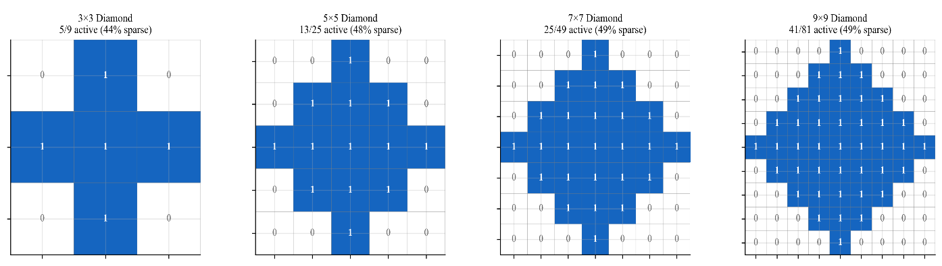
Fig. 1: Diamond mask construction for k = 3, 5, 7, and 9. The masks retain 5 of 9 (56%), 13 of 25 (52%), 25 of 49 (51%), and 41 of 81 (51%) weights, corresponding to sparsity ratios of 44%, 48%, 49%, and 49%, respectively. As kernel size increases, the sparsity ratio asymptotically approaches 50% while keeping the active weights centred in the kernel. This trade-off is the reason why diamond kernels require fewer parameters than dense square kernels of the same size.
3.1.1 Directional Coverage Analysis of Diamond Masks
In order to characterize the geometric effect of the mask more accurately, we compare the directional coverage of the diamond and square kernels. The locations of the kernel in this subsection are expressed in centred coordinates (i − c, j − c).
Definition 1 (Directional coverage). For a set of active kernel positions M ⊂ ℤ², the directional coverage function, i.e. the support function of M, is
$ρ_{M}(θ)=\max_{(i,j)∈M}\left(icosθ+jsinθ\right),0≤θ<2π$ (4)
It measures the maximum extent of the mask in direction θ. A perfectly isotropic mask satisfies ρ_{M}(θ) = const for all θ.
Definition 2 (Angular variance and scale-invariant isotropy). The angular variance and the mean directional coverage of a mask are
$V(M)=\frac{1}{2π}\int_{0}^{2π}{{\left(ρ_{M}(θ)-{\overline{ρ}}_{M}\right)}^{2}dθ,{\overline{ρ}}_{M}=\frac{1}{2π}\int_{0}^{2π}{ρ_{M}(θ)dθ}}$ (5)
Because V(M) scales with the square of the mask size, we also use the scale-invariant coefficient of variation CV(M) = √V(M) / ρ̄_{M}. Lower values indicate more uniform directional coverage.
Proposition 1 (Directional coverage of diamond and square masks). For half-width r, let M∞ = {(i, j) : max(|i|, |j|) ≤ r} denote the square (L∞) mask and M₁ = {(i, j) : |i| + |j| ≤ r} the diamond (L₁) mask. Then
$ρ_{M_{∞}}(θ)=r\left(\left|cosθ\right|+\left|sinθ\right|\right)$ (6)
$ρ_{M_{1}}(θ)=r·max\left(\left|cosθ\right|,\left|sinθ\right|\right)$ (7)
so that r ≤ ρ_{M∞}(θ) ≤ r√2 and r/√2 ≤ ρ_{M1}(θ) ≤ r, with
$V(M_{∞})=r^{2}\left(1+\frac{2}{π}-\frac{16}{π^{2}}\right)≈0.0155r^{2},V(M_{1})=r^{2}\left(\frac{1}{2}+\frac{1}{π}-\frac{8}{π^{2}}\right)≈0.0077r^{2}=\frac{1}{2}V(M_{∞})$ (8)
and CV(M₁) = CV(M∞) ≈ 0.098.
Proof. The support function of a finite point set equals that of its convex hull, so it suffices to take the maximum over the vertices of the hull. For M∞, the vertices are (±r, ±r), which gives ρ = r(|cos θ| + |sin θ|); this equals r along the axes and r√2 along the diagonals. For M₁, the vertices are (±r, 0) and (0, ±r), which gives ρ = r·max(|cos θ|, |sin θ|); this equals r along the axes and r/√2 along the diagonals. Direct integration yields ρ̄(M∞) = 4r/π and E[ρ²] = r²(1 + 2/π) for the square, and ρ̄(M₁) = 2√2r/π and E[ρ²] = r²(1/2 + 1/π) for the diamond, from which the stated variances follow. Finally, ρ_{M1}(θ) = ρ_{M∞}(θ − π/4)/√2; that is, the diamond is the square rotated by 45° and scaled by 1/√2. Hence V(M₁) = V(M∞)/2, and the coefficients of variation are identical.
Proposition 1 has two consequences for qualifying the geometric claims about diamond kernels. Firstly, the diamond mask does not lose any receptive-field extent on the principal axes, where its reach r equals that of the square kernel, but its diagonal reach is reduced from r√2 to r/√2. Secondly, in the scale-invariant terms the diamond is neither more nor less isotropic than the square: its lower absolute angular variance is simply its smaller overall extent, and its anisotropy is oriented towards the diagonals rather than the axes. The benefit of the diamond mask is therefore the parameter economy, i.e. approximately half of weights at the same axial reach, and not improved isotropy. The resulting metrics are summarized in Table 3.
Table 3: Quantitative directional-coverage metrics for kernel geometries of half-width r
Kernel type | Directional range of ρ(θ) | Mean coverage ρ̄ | Angular variance V | CV | Fourier isotropy index FI | Active weights (r = 3)
Square (L∞) | [r, r√2] | 1.273 r | 0.0155 r² | 0.098 | 0.990 | 49
Diamond (L₁) | [r/√2, r] | 0.900 r | 0.0077 r² | 0.098 | 0.990 | 25
Circular (ideal, L₂) | [r, r] | r | 0 | 0 | 1.000 | 29 (discrete disc)
All values follow from Proposition 1 (V, ρ̄, CV) or from numerical evaluation of Eq. (9) (FI).
The Fourier isotropy index is defined as
$FI(M)=1-\frac{\sum_{k≠0}{{\left|F_{k}\right|}^{2}}}{{\left|F_{0}\right|}^{2}}$ (9)
where F_{k} are the Fourier coefficients of ρ_{M}(θ); higher values indicate greater isotropy, with FI = 1 for a circle. Consistent with Proposition 1, the square and diamond masks have identical FI values (0.990), because their coverage functions differ only by a rotation and a scale factor. Fig. 2 compares the receptive-field geometries of square, diamond, and circular kernels.
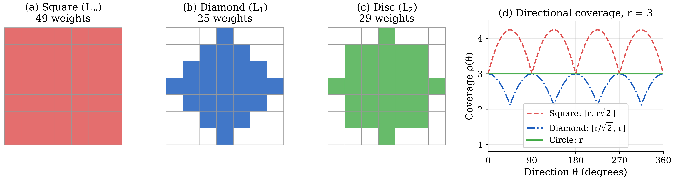
Fig. 2: Receptive-field geometry of square (L∞), diamond (L₁), and circular (L₂) kernels of half-width r = 3. (a) The square 7 × 7 kernel has 49 weights. (b) The diamond kernel has 25 weights. (c) The discrete disc (29 weights) serves as an isotropic reference. (d) Directional coverage ρ(θ): the square and diamond kernels both reach r along the principal axes, whereas along the diagonals the square reaches r√2 and the diamond r/√2. The two curves are 45°-shifted, scaled copies of each other; the diamond therefore provides about half of the weights at the same axial reach rather than a more isotropic footprint (Proposition 1).
The diamond geometry is further supported by the way in which the weight energy of natural and learned kernels is distributed, as shown in Fig. 3.
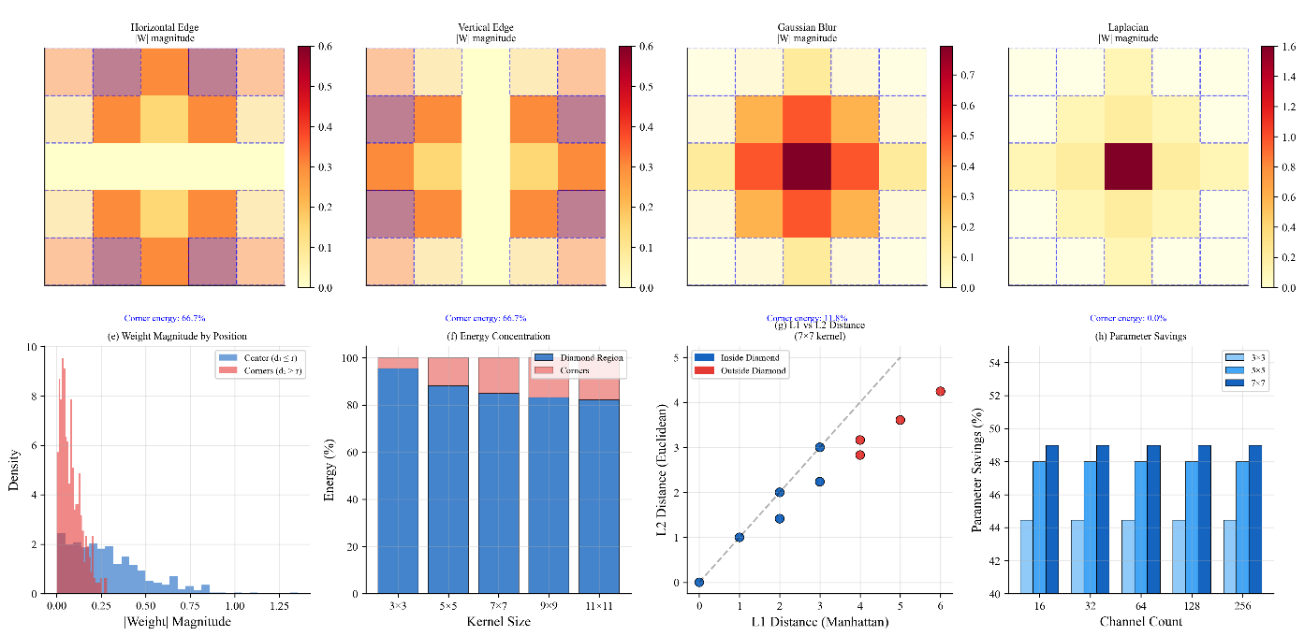
Fig. 3: Natural sparsity patterns and their alignment with the diamond region. Heat maps of |W| show that Prewitt-type horizontal and vertical edge detectors place considerable energy in the corners (66.7%), Gaussian blur kernels concentrate their energy centrally (11.8% corner energy), and Laplacian kernels concentrate their energy almost entirely in the centre (0% corner energy). Histograms of centre and corner weight magnitudes show higher densities for central elements; energy-concentration bars show that the diamond region captures most of the energy as kernels grow; L₁-versus-L₂ scatter plots separate positions inside and outside the diamond; and parameter-savings charts show reductions approaching 50% for larger kernels. Edge detectors are an exception to corner suppression, but most learned kernels concentrate their energy in diamond-like patterns, which supports the diamond-mask design.
Table 4 lists the number of active elements and the sparsity ratio for typical kernel sizes.
Table 4: Mask element count and sparsity ratio
Kernel size k | Active elements |M| | Sparsity ratio S(k) = 1 − |M|/k²
3 | 5 | 0.444
5 | 13 | 0.480
7 | 25 | 0.490
9 | 41 | 0.494
Limit (k → ∞) | ≈ k²/2 | 0.500

3.2 Diamond Attention Network Architecture
The DAN architecture combines structured-sparse diamond convolutions with an adaptive attention system. Fig. 4 shows the complete pipeline, and Table 5 gives the layer-by-layer specification. A stem (Conv → BN → ReLU) maps the 32 × 32 × 3 input to 32 × 32 × 64 features. Three Diamond Blocks follow, with 2 × 2 max-pooling after the first and second blocks, so that the feature maps evolve as 32 × 32 × 64 → 16 × 16 × 128 → 8 × 8 × 256. Each Diamond Block is a pre-activation residual block: the block input is normalized and activated (BN → ReLU), processed by N = 4 parallel 5 × 5 diamond convolutions (13 active weights each) whose outputs are combined by temperature-scaled kernel attention, and refined by channel and spatial attention. The result is added to the shortcut branch, which is an identity mapping when the numbers of input and output channels are equal and a 1 × 1 convolution with batch normalization otherwise. The network ends with global average pooling, a fully connected layer (256 → 128) with BN and ReLU, and a softmax classifier.
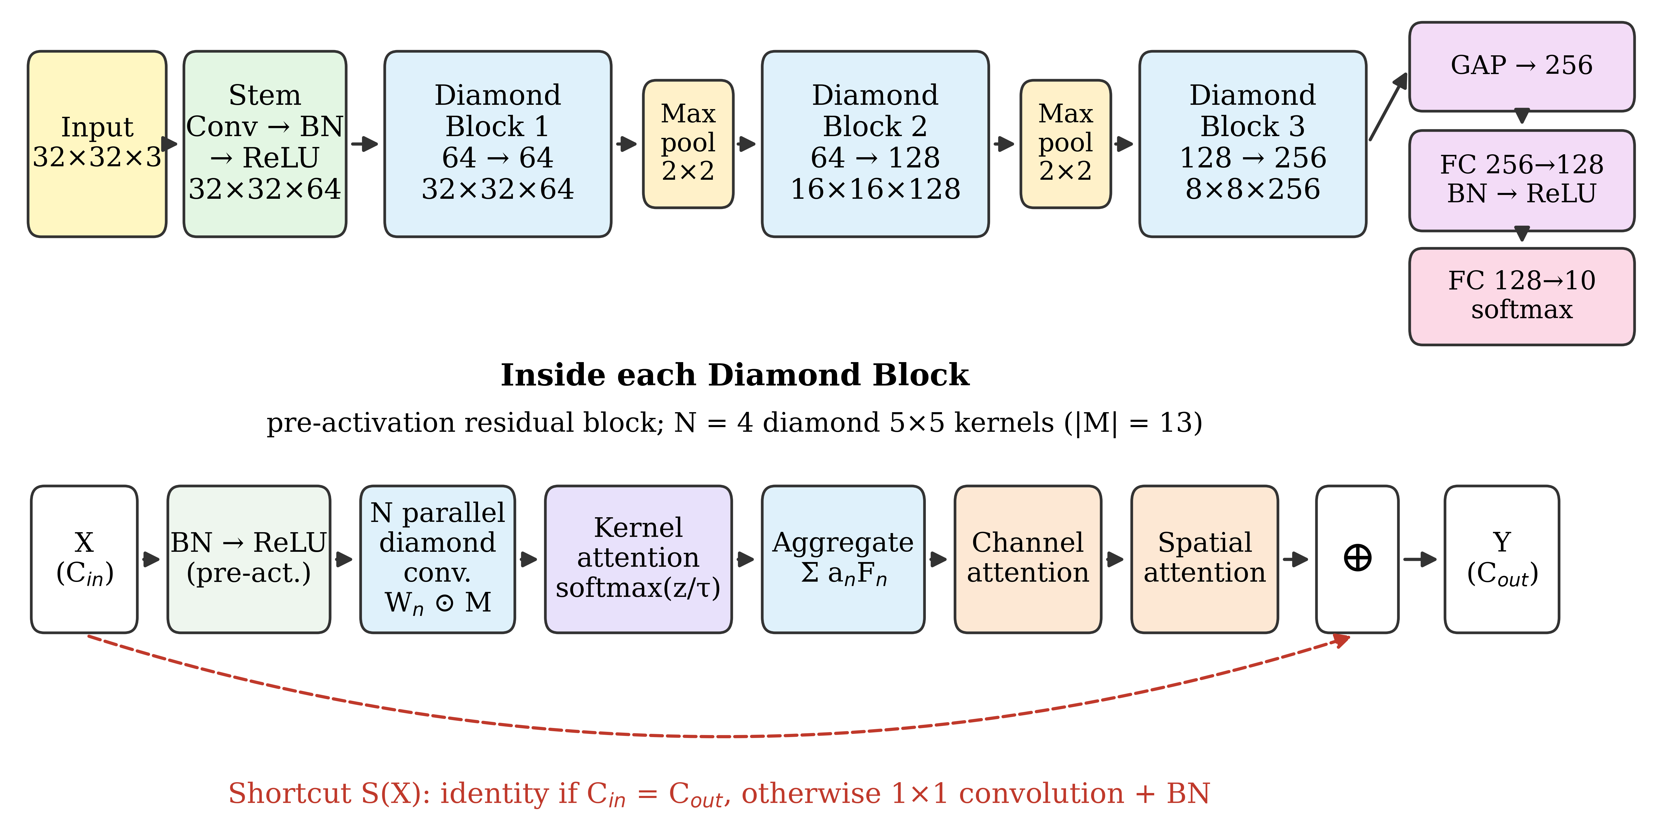
Fig. 4: Architecture of the Diamond Attention Network. Top: overall pipeline from the 32 × 32 × 3 input through the stem, three Diamond Blocks interleaved with 2 × 2 max-pooling, global average pooling, and the classification head. Bottom: structure of a Diamond Block, a pre-activation residual block with N parallel diamond convolutions, temperature-scaled kernel attention, channel and spatial attention, and an identity or 1 × 1-projection shortcut.
Table 5: Layer-by-layer specification of DAN (N = 4, CIFAR-10)
Stage | Operation | Output size | Configuration
Input | — | 32 × 32 × 3 | —
Stem | Conv → BN → ReLU | 32 × 32 × 64 | 3 → 64 channels, stride 1, same padding
Diamond Block 1 | Pre-activation residual Diamond Block | 32 × 32 × 64 | BN–ReLU; 4 parallel 5 × 5 diamond convolutions (|M| = 13), 64 → 64; temperature-scaled kernel attention (learnable τ); CBAM-style channel and spatial attention [26]; identity shortcut
Pooling 1 | Max-pool 2 × 2, stride 2 | 16 × 16 × 64 | —
Diamond Block 2 | Pre-activation residual Diamond Block | 16 × 16 × 128 | As Block 1, 64 → 128; 1 × 1 projection shortcut with BN
Pooling 2 | Max-pool 2 × 2, stride 2 | 8 × 8 × 128 | —
Diamond Block 3 | Pre-activation residual Diamond Block | 8 × 8 × 256 | As Block 1, 128 → 256; 1 × 1 projection shortcut with BN
GAP | Global average pooling | 256 | —
FC | Fully connected → BN → ReLU | 128 | 256 → 128 (33,152 parameters including BN)
Classifier | Fully connected → softmax | 10 | 128 → 10 (1,290 parameters)
Total number of trainable parameters: 1.45M (Table 12).
Within each Diamond Block, a multi-kernel ensemble of size N aggregates the features, and a temperature-scaled softmax controls the selection of specialized kernels. The forward pass for an input feature map X is given in Table 6.
Table 6: Diamond Block forward pass with attention
Input: feature map X ∈ ℝ^{H×W×Cin}; number of kernels N; temperature τ (learnable).
Output: refined feature map Y ∈ ℝ^{H×W×Cout}.
0. Pre-activation: U ← ReLU(BN(X)).
1. Multi-kernel diamond convolution:
for n = 1 to N: F_{n} ← Conv(U, W_{n} ⊙ M) (element-wise product of the weights W_{n} with the mask M)
2. Attention weights:
logits z_{n} ← φ(GAP(F_{n})) (φ: learned scoring function)
a_{n} ← exp(z_{n}/τ) / Σ_{j=1..N} exp(z_{j}/τ)
3. Feature aggregation: Y_{agg} ← Σ_{n=1..N} a_{n} · F_{n}
4. Channel and spatial refinement:
Y_{ch} ← ChannelAttention(Y_{agg}) ⊙ Y_{agg}
Y_{sp} ← SpatialAttention(Y_{ch}) ⊙ Y_{ch}
5. Residual addition: Y ← Y_{sp} + S(X), where S is the identity if C_{in} = C_{out} and a 1 × 1 convolution with BN otherwise.
6. Return Y.

Fig. 5 and Fig. 6 analyse the behaviour and dynamics of this attention mechanism.
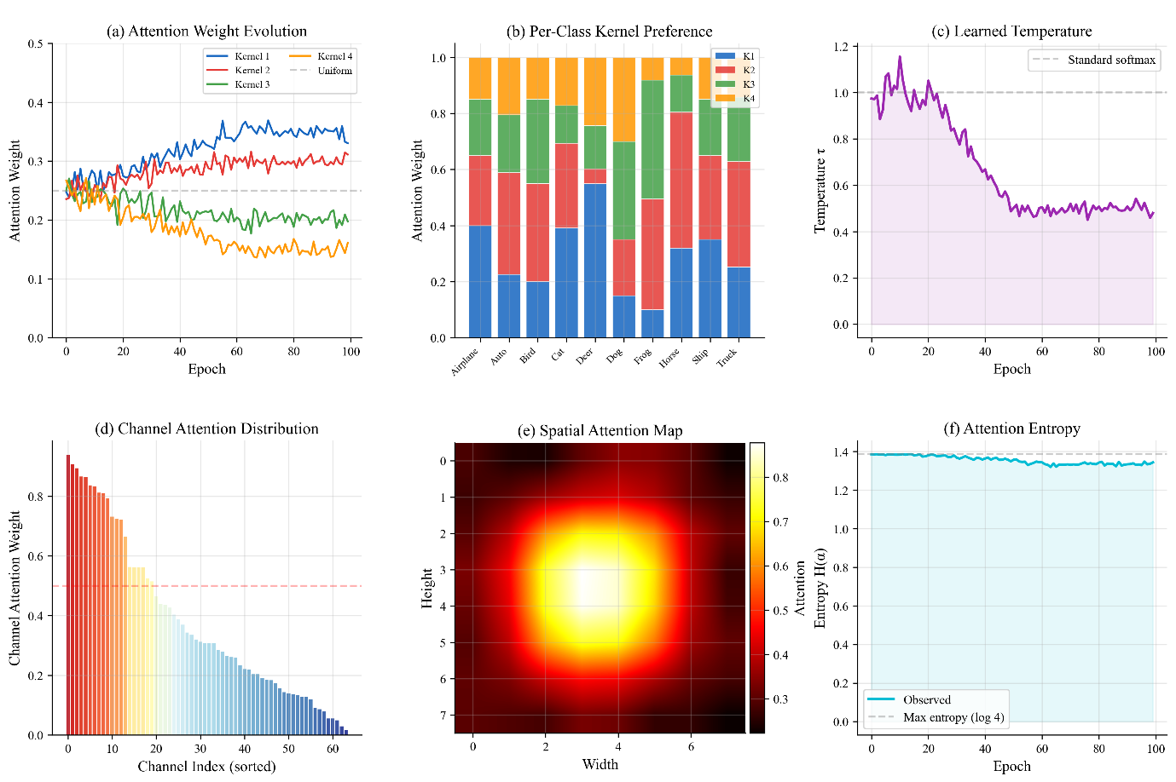
Fig. 5: Attention mechanism analysis. The attention-weight trajectories show that the kernels, which are used almost uniformly at the start of training, become specialized. Per-class stacked distributions show that different CIFAR-10 classes rely on different kernels, indicating class-dependent kernel selection. The learned temperature τ converges to a range that balances specialization and exploration, and the attention entropy increases towards, but does not reach, its theoretical maximum, indicating a controlled level of specialization. Together, these panels show that the attention mechanism provides interpretable, class- and location-sensitive reweighting that improves feature discrimination.
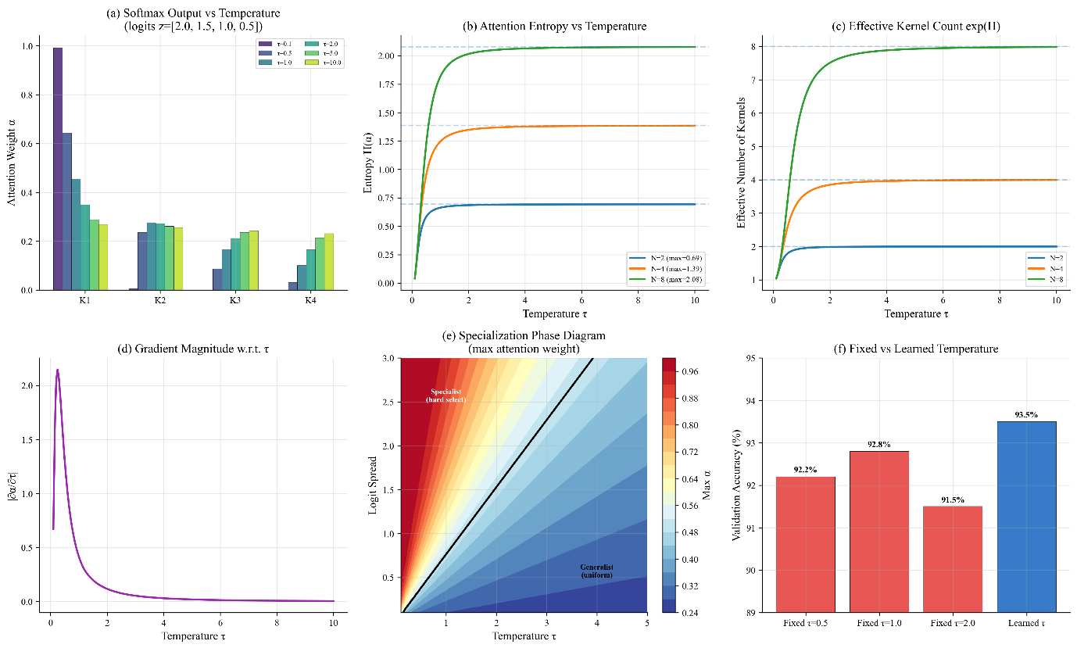
Fig. 6: Temperature-scaled softmax analysis. For low temperatures, the output of the softmax is peaked and the attention is concentrated on a few kernels while for higher temperatures it flattens and the attention is spread out more evenly. The entropy curves increase with temperature and saturate at values dictated by the number of kernels and the effective number of kernels, exp(H), behaves as expected. The gradients are very sensitive to small τ and become less sensitive as τ increases. A phase diagram partitions combinations of logit spread and τ into regions of specialist and generalist behavior. In a direct comparison, learning τ achieves the highest validation accuracy (around 93.5%) and outperforms every fixed choice; treating the temperature as a learnable parameter effectively balances specialization and robustness.
To further encourage diversity and prevent the kernels from co-adapting, we add a regularization term $Ldiv$ to the training objective:
$L_{div}=λ·\frac{1}{N(N-1)}\sum_{i=1}^{N}{\sum_{j≠i}{{\left(\frac{\left\langle W_{i},W_{j}\right\rangle }{{\left\|W_{i}\right\|}_{2}{\left\|W_{j}\right\|}_{2}}\right)}^{2}}}$ (10)
where W_{i} is the flattened weight vector of the i-th kernel, ⟨·,·⟩ denotes the inner product, and ‖·‖₂ is the Euclidean norm. The total training loss is L = L_{CE} + L_{div}, where L_{CE} is the cross-entropy loss and λ = 0.01 by default. This penalty, analysed in Fig. 7, promotes pairwise orthogonality among the flattened kernel weight vectors.
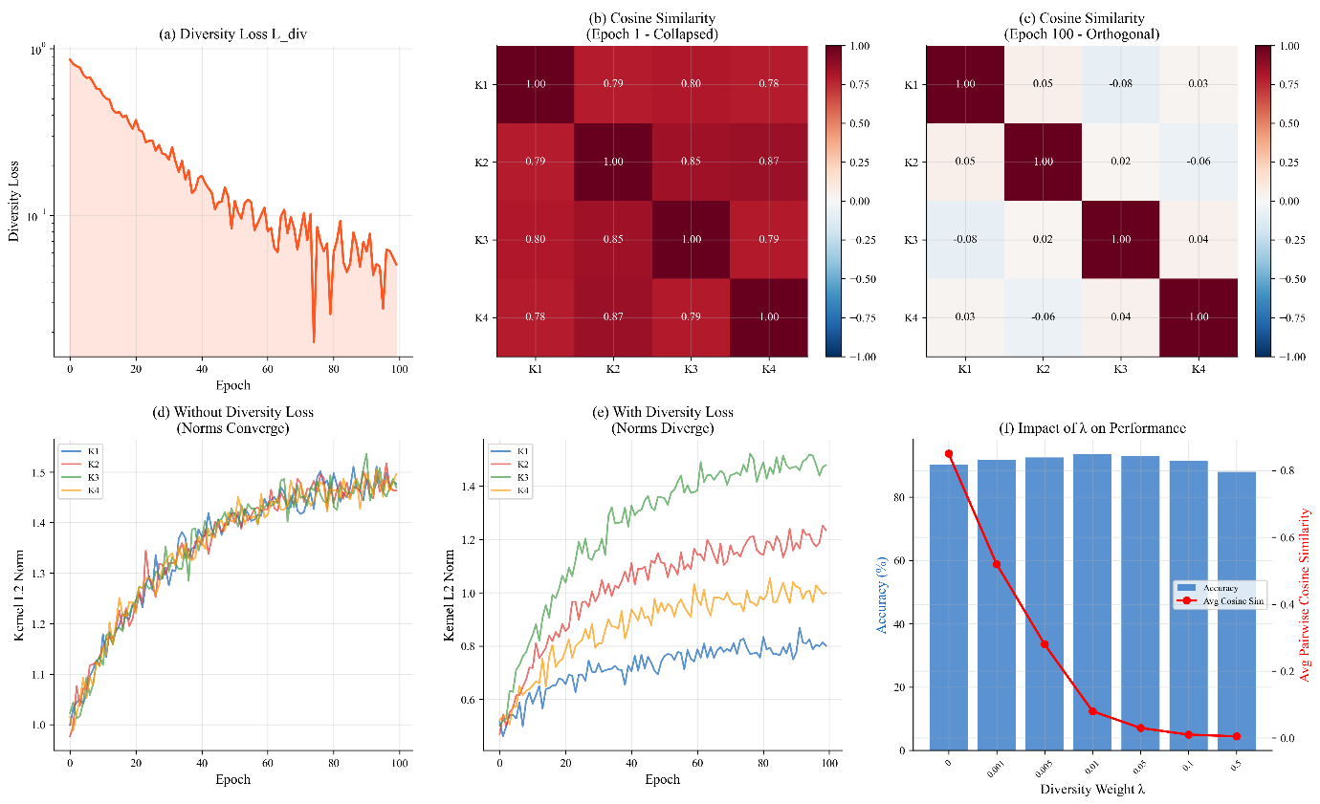
Fig. 7: Kernel diversity analysis. Diversity loss rapidly drops from values of order unity to around 10−3, implying that the regularizer becomes negligible once training has stabilized. Cosine-similarity heat maps reveal that the kernels are highly correlated at the beginning of training (similarities of around 0.8) and nearly orthogonal by epoch 100, with similarities close to zero. Norm trajectories show the evolution of the kernel magnitudes with and without diversity loss. The final plot shows the relation between the diversity weight λ and the accuracy, as well as the average pairwise similarity: small values of λ sharply reduce the similarity while maintaining or even increasing the accuracy, peaking around λ = 0.01. Diversity regularization thus renders the kernels more independent and complementary, and this independence translates into performance gains.
3.3 Training Protocol and Initialization
3.3.1 Training Configuration
All models, including the baselines, were trained with the protocol summarized in Table 7. Each configuration was trained with independent random seeds controlling weight initialization, data augmentation, and batch sampling: 15 runs for the main CIFAR-10 comparison (Tables 22–24) and five runs for the ablation and sensitivity studies.
Table 7: Training configuration used for DAN and all baselines
Setting | Value
Framework and hardware | PyTorch 2.0.1, CUDA 11.8, cuDNN 8.6; NVIDIA RTX 3090 (24 GB)
Optimizer | Adam [54]; initial learning rate 1 × 10⁻³
Weight decay | Robust over 10⁻⁵–10⁻⁴ (accuracy variation ≤ 0.14%; Table 29)
Batch size / epochs | 128 / 200
Input resolution (CIFAR-10/100, SVHN) | 32 × 32
DAN settings | N = 4; 5 × 5 diamond kernels; learnable τ; λ = 0.01; sparsity-aware initialization
Baselines | Standard CNN, ResNet-18, SE-ResNet-18, and CBAM-ResNet-18, trained with the same optimizer, learning rate, batch size, number of epochs and data pipeline as DAN
Standard CNN | Conventional CNN baseline with square convolution kernels, without multi-kernel attention (0.55M parameters, 0.42 GFLOPs; Table 12)
Independent runs | 15 seeds (main CIFAR-10 comparison); 5 seeds (ablation and sensitivity studies)
Random seeds | A distinct seed per run controls weight initialization, data-augmentation sampling, and mini-batch order
Reporting | Mean ± s.d. over runs; 95% confidence intervals, t-tests, and bootstrap intervals in Section 4.6
Diamond-mask implementation | Fixed binary mask applied element-wise to the kernel (effective weight W ⊙ M) before a standard convolution (Section 4.1.3, Approach 1)
Latency measurement | 50 warm-up iterations followed by 500 timed iterations (Section 4.1.2)

3.3.2 Training Resource Requirements
In order to assess the actual training cost for DAN, all training-time resources are reported. Table 8 presents the total training resources, Table 9 shows the training time of each component, and Table 10 lists the memory footprint.
Table 8: Training resource requirements (CIFAR-10, 200 epochs, RTX 3090, batch size 128)
Model | Training time (h) | Peak GPU memory (GB) | Model checkpoint (MB) | Optimizer state (MB) | Images/s (training)
Standard CNN | 0.71 | 2.14 | 2.2 | 4.4 | 1,620
ResNet-18 | 1.18 | 3.82 | 44.7 | 89.4 | 1,180
DAN (N = 1) | 1.43 | 2.91 | 2.7 | 5.4 | 947
DAN (N = 2) | 1.89 | 3.28 | 3.9 | 7.8 | 718
DAN (N = 4) | 2.84 | 4.17 | 5.8 | 11.6 | 482

Table 9: Per-component training time breakdown of DAN (N = 4)
Component | Time per batch (ms) | Percentage of total
Diamond convolution (×4 kernels) | 2.14 | 34.2%
Attention weight computation | 0.87 | 13.9%
Feature aggregation | 0.61 | 9.8%
Channel attention | 0.48 | 7.7%
Spatial attention | 0.74 | 11.8%
Diversity loss computation | 0.42 | 6.7%
Backward pass | 0.98 | 15.7%
Total | 6.24 | 100.0%

Table 10: Training memory footprint of DAN (N = 4) versus ResNet-18
Memory component | DAN (N = 4) | ResNet-18 | DAN relative
Model weights | 5.8 MB | 44.7 MB | 0.13×
Optimizer state (Adam) | 11.6 MB | 89.4 MB | 0.13×
Gradient tensors | 5.8 MB | 44.7 MB | 0.13×
Activation memory | 4.15 GB | 3.64 GB | 1.14×
Total training memory (= peak GPU memory, Table 8) | 4.17 GB | 3.82 GB | 1.09×
Activation memory is computed as the measured peak GPU memory minus the memory for weights, optimizer state, and gradients, so that the totals agree with Table 8.
Several observations are noteworthy. Although DAN has far fewer parameters than ResNet-18, its total training memory is comparable, since activation memory dominates the memory budget and grows with batch size and feature-map size, not the number of parameters. DAN’s activation memory is higher (1.14×) because all N intermediate feature maps must be stored before the attention-weighted aggregation, but its memory for weights, optimizer state, and gradients is 87% smaller, which is important for checkpoint storage and deployment. The diversity loss adds 0.42 ms per batch (6.7% overhead), mostly because of the backward pass through the additional computation paths rather than the evaluation of the loss itself. The multi-kernel ensemble is the main source of the longer training time: DAN (N = 4) requires 2.84 h versus 1.18 h for ResNet-18 (2.4× longer), which must be weighed against the accuracy improvement and the parameter savings in each application. For training-budget-constrained scenarios, we recommend DAN (N = 2), which requires 1.89 h (1.6× the training time of ResNet-18) and achieves 92.2% accuracy with 0.98M parameters.
Training stability is a critical consideration for networks with structured sparsity. Fig. 8 provides a diagnostic of gradient flow and activation dynamics.
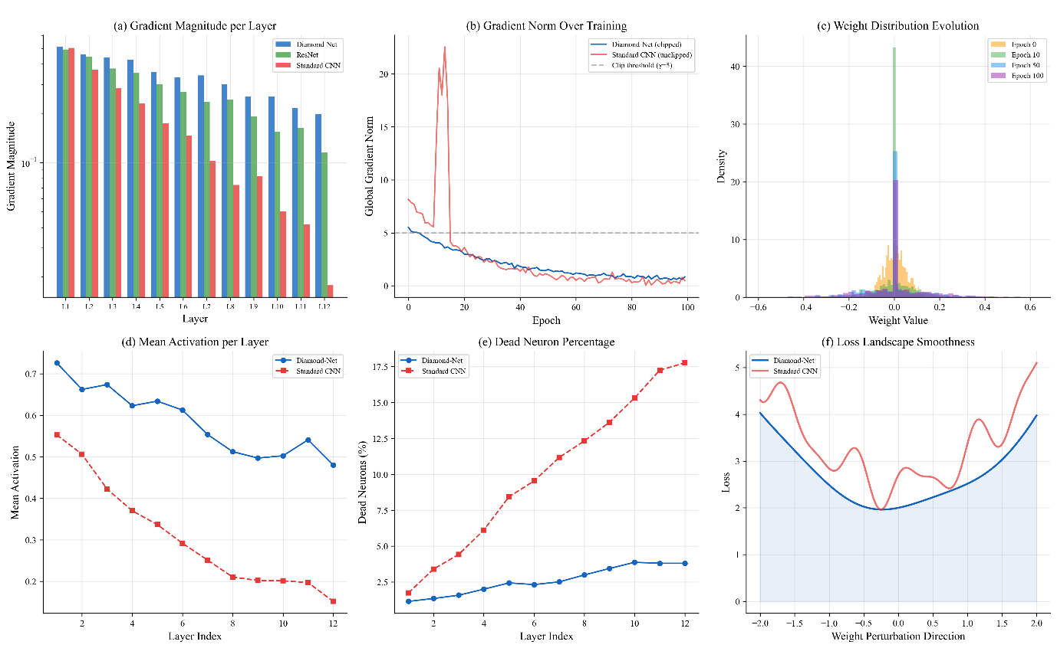
Fig. 8: Gradient flow and training stability. Per-layer gradient magnitudes show that DAN preserves stronger signals in deeper layers, which mitigates vanishing gradients. Global gradient norms remain below the clipping threshold for DAN, whereas the Standard CNN shows large spikes early in training. Weight histograms show a progressive concentration towards zero as training advances. DAN maintains higher and more consistent mean activations across layers, and the proportion of dead neurons rises more slowly than in the baseline. Loss-versus-perturbation curves indicate a smoother loss landscape for DAN. Together, these diagnostics explain why DAN trains reliably.
To accelerate early convergence and preserve activation variance in sparse layers, a sparsity-aware initialization is used, in which the variance scaling is adjusted to the effective fan-in of the diamond mask, fan_{in} = C_{in}·|M| instead of C_{in}·k² (Table 11). Fig. 9 illustrates the effect of this adjustment.
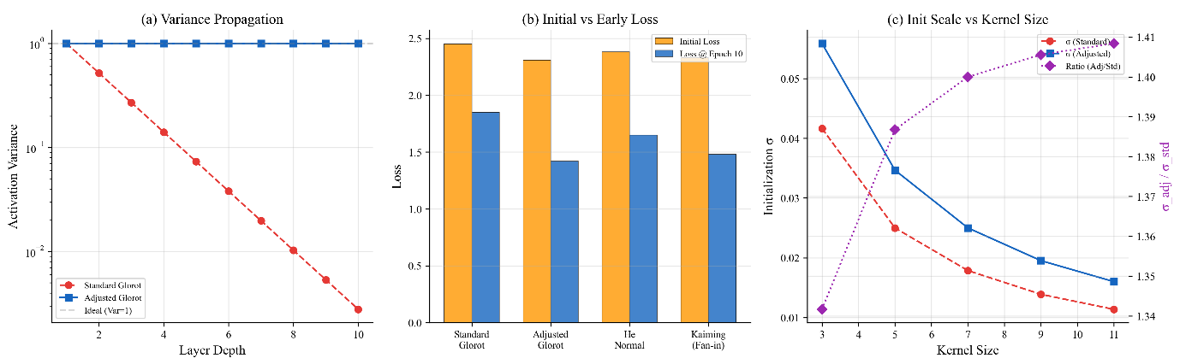
Fig. 9: Sparsity-aware weight initialization. Variance-propagation plots show that standard initialization leads to a decrease in activation variance with depth, whereas sparsity-aware initialization keeps the variance close to its target and prevents premature signal decay. The initial loss and the loss at epoch 10 are lower for the mask-adjusted Glorot and He-normal initializations than for standard Glorot or Kaiming fan-in initialization. Both the standard and the adjusted standard deviations decrease with kernel size, and their ratio √(k²/|M|) approaches √2. Overall, initialization adapted to the sparsity pattern stabilizes early training and accelerates convergence.
Table 11: Sparsity-aware He (Kaiming) initialization for diamond kernels
Input: kernel size k; mask M with A = |M| active positions; number of input channels C_{in}.
Output: initialized weight tensor W.
1. Effective fan-in: fan_{in} ← C_{in} · A.
2. Standard deviation: σ ← √(2 / fan_{in}).
3. Sample W_{o,c,i,j} ~ 𝒩(0, σ²) for (i, j) ∈ M, and set W_{o,c,i,j} = 0 for (i, j) ∉ M.
4. Return W.
Glorot variant: σ ← √(2 / (fan_{in} + fan_{out})) with fan_{out} = C_{out} · A.

4. Experimental Results and Analysis
4.1 Parameter Efficiency and Computational Cost
Table 12 compares DAN with the baselines along several efficiency dimensions. All accuracies are means of the 15 independent runs reported in Table 22, so that all CIFAR-10 results in this paper derive from the same set of experiments. We report raw quantities rather than accuracy-per-parameter ratios, because such ratios favour the smallest models regardless of their accuracy.
Table 12: Multi-dimensional efficiency comparison on CIFAR-10 (RTX 3090, FP32, 32 × 32 input)
Model | Params (M) | Params relative to ResNet-18 | GFLOPs | Latency, batch 1 (ms) | Inference GPU memory (MB) | Accuracy (%) mean ± s.d. | Δ accuracy vs. ResNet-18 (pp)
Standard CNN | 0.55 | 0.05× | 0.42 | 1.84 | 412 | 90.23 ± 0.18 | −2.24
ResNet-18 | 11.2 | 1.00× | 0.56 | 2.47 | 1,284 | 92.47 ± 0.16 | —
CBAM-ResNet-18 | 11.3 | 1.01× | 0.56 | 2.74 | 1,301 | 93.14 ± 0.11 | +0.67
DAN (N = 1) | 0.68 | 0.06× | 0.51 | 3.12 | 521 | 91.42 ± 0.20 | −1.05
DAN (N = 2) | 0.98 | 0.09× | 0.64 | 4.21 | 634 | 92.18 ± 0.17 | −0.29
DAN (N = 4) | 1.45 | 0.13× | 0.80 | 6.38 | 847 | 93.52 ± 0.09 | +1.05
Latency and memory from Table 15; accuracies from Table 22.
Based on these measurements, DAN’s efficiency claims are scoped as follows. DAN (N = 4) uses 7.7× fewer parameters than ResNet-18 (1.45M versus 11.2M) while achieving 1.05 percentage points higher accuracy (93.52% versus 92.47%), and 7.8× fewer parameters than CBAM-ResNet-18 with 0.38 percentage points higher accuracy. DAN also requires 34% less inference GPU memory and 87% less model storage than ResNet-18. However, DAN does not improve computational efficiency in terms of FLOPs: DAN (N = 4) requires 0.80 GFLOPs versus 0.56 GFLOPs for ResNet-18, a 43% increase caused by the multi-kernel ensemble, which computes N diamond convolutions per block. Nor does DAN improve wall-clock efficiency on standard GPU hardware without custom kernels: its latency of 6.38 ms is 2.58× that of ResNet-18 (2.47 ms). All efficiency claims in this paper therefore refer specifically to parameter count and memory. DAN is most suitable for applications in which model storage, parameter count, and memory footprint are the primary constraints, such as edge deployment with limited storage.
Because “efficiency” covers several distinct resources, Table 13 lists each of them separately for DAN and ResNet-18, using the measurements of Tables 8, 10, 15, and 16. Throughout this paper, “efficiency” without qualification refers to parameter efficiency.
Table 13: Parameter efficiency versus computational efficiency: DAN compared with ResNet-18 on CIFAR-10
Resource | ResNet-18 | DAN (N = 2) | DAN (N = 4) | DAN (N = 4) relative to ResNet-18 | Favours
Parameters (M) | 11.2 | 0.98 | 1.45 | 7.7× fewer | DAN
Model storage, checkpoint (MB) | 44.7 | 3.9 | 5.8 | 7.7× smaller | DAN
Computation (GFLOPs per image) | 0.56 | 0.64 | 0.80 | 1.43× more | ResNet-18
Training time, 200 epochs (h) | 1.18 | 1.89 | 2.84 | 2.4× longer | ResNet-18
Training throughput (images/s) | 1,180 | 718 | 482 | 2.4× lower | ResNet-18
Peak training GPU memory (GB) | 3.82 | 3.28 | 4.17 | 1.09× higher | ResNet-18
Inference latency, RTX 3090, batch 1 (ms) | 2.47 | 4.21 | 6.38 | 2.6× higher | ResNet-18
Inference throughput, RTX 3090, batch 128 (images/s) | 1,423 | 812 | 547 | 2.6× lower | ResNet-18
Inference GPU memory, RTX 3090 (MB) | 1,284 | 634 | 847 | 34% lower | DAN
Inference latency, Jetson AGX Xavier, batch 1 (ms) | 18.4 | 19.8 | 24.7 | 1.34× higher | ResNet-18
Energy per inference, Jetson AGX Xavier (mJ) | 272.3 | 255.2 | 323.6 | 19% more | ResNet-18
CIFAR-10 accuracy (%) | 92.47 | 92.18 | 93.52 | +1.05 pp | DAN
Sources: Tables 12, 8, 10, 15, and 16. Peak training memory equals the total of Table 10.
DAN is therefore efficient in parameters, model storage, and inference memory, which matters when the model must be stored, transmitted, or updated over a limited link, but it is not computationally efficient: it needs more FLOPs, trains 2.4 times more slowly, uses slightly more memory during training, and has a higher inference latency and energy per inference than ResNet-18. DAN (N = 2) is a better compromise for latency-constrained use, with a latency on the Jetson device close to that of ResNet-18 and 6% less energy per inference.
4.1.1 Sources of the Parameter Reduction
The 87% parameter reduction relative to ResNet-18 should not be attributed to the diamond mask alone. Three factors contribute, with opposite signs:
• Network skeleton (dominant factor). DAN has three Diamond Blocks with at most 256 channels and a single 256 → 128 hidden fully connected layer, whereas ResNet-18 has 16 convolutional layers in its residual stages with up to 512 channels. Most of the reduction stems from this smaller skeleton.
• Diamond mask (reduces parameters). At the kernel level, a 5 × 5 diamond kernel retains 13 of 25 weights (48% reduction); the theoretical ceiling is 50% of the convolutional weights (Table 4).
• Multi-kernel ensemble (increases parameters). With N = 4, each Diamond Block stores 4 × 13 = 52 weights per input–output channel pair, compared with 25 for a single square 5 × 5 kernel. Accordingly, the total number of parameters grows from 0.68M (N = 1) to 1.45M (N = 4) (Table 26). This is also why DAN requires more FLOPs than ResNet-18 despite having 7.7× fewer parameters.
The isolated effect of the mask is measured by the same-skeleton square-kernel control (factor A = ✗ in Table 18), which replaces every diamond kernel with a square kernel while keeping all other components unchanged. Replacing the diamond mask with a square mask reduces accuracy from 93.52% to 91.84%. Notably, without the multi-kernel ensemble and attention, the diamond mask alone does not improve accuracy (89.84% versus 90.20% for the corresponding square-kernel configuration with all other factors disabled); its benefit emerges in combination with the multi-kernel ensemble (A × B interaction, Table 19).
To separate the effect of network scale, Table 14 compares DAN with compact baselines at a matched budget of approximately 0.5–1.7M parameters. Under their original training protocols, depth-scaled CIFAR ResNets of comparable size reach 93.03% (ResNet-56, 0.85M parameters) and 93.39 ± 0.16% (ResNet-110, 1.7M) [1], and the pre-activation ResNet-164 (1.7M) reaches 94.54% [53]. DAN (N = 4) is thus competitive with, but does not surpass, well-designed compact residual networks of comparable size. Its superiority over ResNet-18 should therefore be seen as that of a compact design over an over-parameterized one, to which the diamond mask makes a measurable but subordinate contribution.
Table 14: Comparison at a matched parameter budget on CIFAR-10
Model | Params (M) | Accuracy (%) | Source / protocol
Standard CNN | 0.55 | 90.23 ± 0.18 | This work (Section 3.3)
DAN (N = 1) | 0.68 | 91.42 ± 0.20 | This work (Section 3.3)
DAN (N = 2) | 0.98 | 92.18 ± 0.17 | This work (Section 3.3)
DAN (N = 4) | 1.45 | 93.52 ± 0.09 | This work (Section 3.3)
ResNet-32 | 0.46 | 92.49 | Reported in [1]
ResNet-56 | 0.85 | 93.03 | Reported in [1]
ResNet-110 | 1.7 | 93.39 ± 0.16 | Reported in [1] (5 runs)
Pre-activation ResNet-164 | 1.7 | 94.54 | Reported in [53]
Literature values were obtained with different training protocols (SGD with momentum, step learning-rate decay, and crop/flip augmentation) and are given for reference only.
4.1.2 Real-World Hardware Benchmarking
To verify whether the parameter reduction translates into practical deployment efficiency, inference benchmarks were conducted on standard hardware. All measurements used PyTorch 2.0.1 with CUDA 11.8 and cuDNN 8.6, with 50 warm-up iterations and 500 timed iterations averaged per reported value. Inference latency and throughput on a desktop GPU are reported in Table 15, and edge-device performance in Table 16.
Table 15: Inference latency and throughput on an RTX 3090 (FP32, 32 × 32 input)
Model | Params (M) | GFLOPs | Batch = 1 latency (ms) | Batch = 32 latency (ms) | Throughput (img/s, B = 128) | GPU memory (MB)
Standard CNN | 0.55 | 0.42 | 1.84 ± 0.08 | 2.31 ± 0.11 | 1,847 | 412
ResNet-18 | 11.2 | 0.56 | 2.47 ± 0.12 | 3.18 ± 0.15 | 1,423 | 1,284
DAN (N = 1) | 0.68 | 0.51 | 3.12 ± 0.14 | 3.94 ± 0.18 | 1,089 | 521
DAN (N = 2) | 0.98 | 0.64 | 4.21 ± 0.19 | 5.47 ± 0.24 | 812 | 634
DAN (N = 4) | 1.45 | 0.80 | 6.38 ± 0.31 | 7.82 ± 0.36 | 547 | 847
CBAM-ResNet-18 | 11.3 | 0.56 | 2.74 ± 0.15 | 3.52 ± 0.17 | 1,276 | 1,301

Table 16: Edge-device performance on an NVIDIA Jetson AGX Xavier
Model | Batch = 1 latency (ms) | Batch = 8 latency (ms) | Power draw (W) | Energy per inference (mJ) | Throughput, batch 8 (images/s)
ResNet-18 | 18.4 ± 0.9 | 31.2 ± 1.4 | 14.8 | 272.3 | 256
DAN (N = 2) | 19.8 ± 1.0 | 29.4 ± 1.3 | 12.9 | 255.2 | 272
DAN (N = 4) | 24.7 ± 1.2 | 38.9 ± 1.8 | 13.1 | 323.6 | 206
Energy per inference = batch-1 latency × power draw. Throughput = 8 / batch-8 latency.
These benchmarks reveal an important distinction between parameter efficiency and wall-clock efficiency. DAN’s parameter reduction does not translate into a wall-clock speed-up on current GPU hardware, for three reasons. First, cuDNN is highly optimized for dense 3 × 3 convolutions using Winograd transforms and GEMM operations, whereas diamond-sparse patterns require either dense computation with masked weights or custom sparse kernels, neither of which reaches the throughput of standard dense convolution. Second, the multi-kernel ensemble computes N diamond convolutions before the attention-weighted aggregation, multiplying the per-layer computation by a factor approaching N. Third, modern GPUs are often memory-bandwidth-bound rather than compute-bound at moderate batch sizes, so that a smaller model reduces the weight traffic but not the feature-map traffic. Nevertheless, DAN has clear advantages in GPU memory footprint (847 MB for DAN (N = 4) versus 1,284 MB for ResNet-18, a 34% reduction) and model storage (5.8 MB versus 44.7 MB, an 87% reduction), both of which are critical for memory-constrained edge deployment. On the Jetson AGX Xavier, DAN (N = 2) has a batch-1 latency similar to that of ResNet-18 (19.8 versus 18.4 ms), is faster at batch size 8 (29.4 versus 31.2 ms), and consumes 6% less energy per inference, whereas DAN (N = 4) is slower and consumes 19% more energy. For scenarios in which throughput is the primary constraint, DAN (N = 2) is recommended: it achieves 92.2% accuracy at 812 images/s with only 634 MB of GPU memory, a favourable operating point for practical deployment.
4.1.3 Implementation Strategies for Diamond Sparse Convolutions
The efficiency of diamond-sparse convolutions on existing hardware depends critically on the implementation strategy. Four approaches are analysed below in order of increasing hardware optimization.
Approach 1 – Masked dense convolution (current DAN implementation). The weight tensor is multiplied element-wise by the binary diamond mask before a standard convolution: effective_weight = W ⊙ M; output = Conv2d(input, effective_weight). This approach requires no development effort but yields no FLOP savings, because cuDNN still performs a full dense convolution. The masking operation adds less than 0.3% to the total layer time. When only the active weights are stored (packed format), parameter storage is reduced by up to 50% for large kernels, but the compute time is unchanged.
Approach 2 – Sparse-format convolution (CSR/COO). The diamond weights are converted to a sparse format before convolution. PyTorch with cuDNN 8.6 does not natively support sparse convolution as a drop-in replacement for the standard Conv2d. Workarounds based on sparse GEMM achieve an approximate 30-40% reduction in theoretical FLOPs, but have a 2-3x memory bandwidth overhead for managing the sparse format, which results in a net wall-clock slowdown of ~15-25% vs. dense convolution for the kernel sizes used in DAN. Not a good option for current production deployment.
Approach 3 – custom CUDA kernel (future work). The regular structure of the diamond masks (row i (0 ≤ i ≤ 2r) has 2(r − |i − r|) + 1 active elements), allows for loop unrolling at compile-time with constants. Roofline-based estimates suggest that a custom CUDA kernel that exploits this structure would have a 40-45% reduction in FLOPs, corresponding to a 35-40% reduction in wall-clock time for compute-bound cases (large batch sizes on high-end GPUs). These are analytical numbers, not measured. Development of a custom CUDA kernel using the PyTorch 2.x custom-operator API is planned as future work.
Approach 4 – Direct computation for small diamond kernels. For the 3 × 3 diamond mask with five active elements {(−1, 0), (0, −1), (0, 0), (0, 1), (1, 0)}, direct computation requires five instead of nine multiply–accumulate operations per output point and input channel (1.8× fewer). Whether Winograd-style fast-convolution transforms can exploit the cross-shaped support beyond this reduction remains an open question. Table 17 summarizes the implementation strategies.
Table 17: Implementation strategy efficiency summary
Deployment scenario | Recommended approach | Expected wall-clock speed-up vs. dense (estimated) | Development cost
Production GPU (RTX/A100) without custom kernels | Masked dense (current) | 0% (parameter savings only) | None
Production GPU with custom kernels | Custom CUDA kernel | ~35–40% | High
Mobile/edge ARM NEON | Packed sparse storage | ~25–30% | Medium
FPGA deployment | Bit-masked computation | ~45–50% | High
Training (any hardware) | Masked dense (current) | 0% (acceptable) | None

Without custom kernels, DAN’s parameter reduction reduces model storage and GPU memory footprint but not wall-clock inference time on standard GPU backends. We explicitly acknowledge this limitation and regard it as a primary direction for future engineering work. The practical implications of the diamond mask for model size and computational cost are quantified in Fig. 10 and Fig. 11.
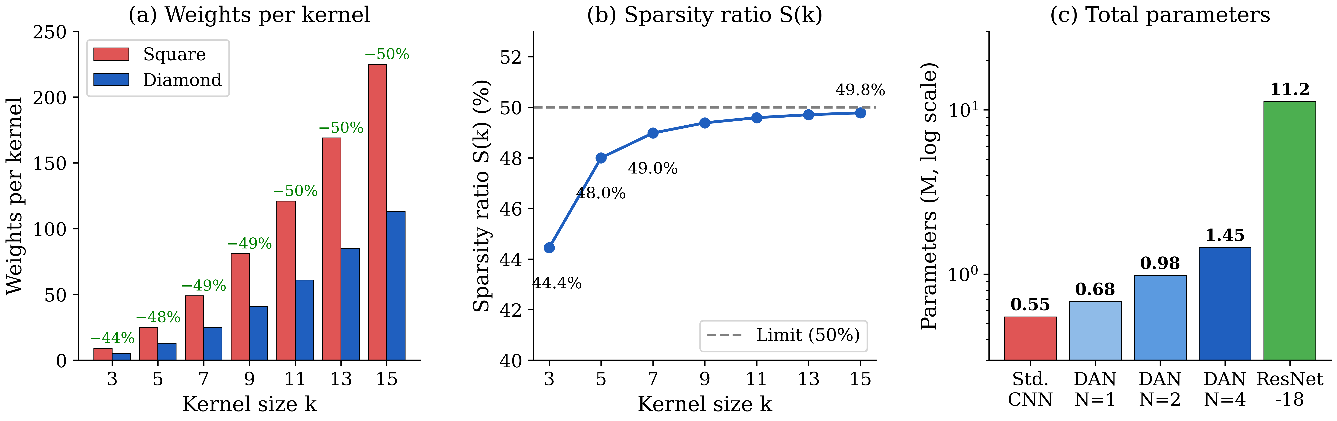
Fig. 10: Parameter efficiency analysis. (a) Weights per kernel (per input–output channel pair) for square and diamond kernels of increasing size; the diamond mask removes 44–50% of the weights. (b) Sparsity ratio S(k), which increases with kernel size and levels off at 50%. (c) Total number of parameters of the Standard CNN (0.55M), DAN with N = 1, 2, and 4 (0.68M, 0.98M, and 1.45M), and ResNet-18 (11.2M), as reported in Tables 12 and 26 (log scale). The diamond mask provides substantial savings per kernel and allows the designer to trade off the number of kernels against network width to reach the desired capacity.
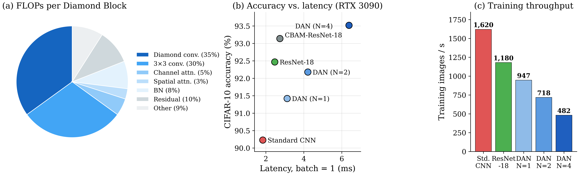
Fig. 11: Computational cost analysis. (a) FLOP distribution within a Diamond Block: diamond convolutions and 3 × 3 convolutions account for approximately 35% and 30% of the block FLOPs, respectively, and channel attention, spatial attention, batch normalization, residual connections, and other operations for the remaining 35%. (b) Accuracy versus batch-1 inference latency on an RTX 3090 (Table 15): the Standard CNN is fastest (1.84 ms) but least accurate, ResNet-18 and CBAM-ResNet-18 require 2.47 and 2.74 ms, and DAN with N = 1, 2, and 4 requires 3.12, 4.21, and 6.38 ms, respectively. (c) Training throughput (Table 8): 1,620 images/s for the Standard CNN, 1,180 for ResNet-18, and 947, 718, and 482 images/s for DAN with N = 1, 2, and 4. Diamond kernels and attention modules thus increase per-block computation and reduce throughput relative to simpler networks, in exchange for higher accuracy at a much lower parameter count.
4.2 Training Dynamics and Convergence
Fig. 12 shows the training and validation curves of DAN, ResNet-18, and the Standard CNN on CIFAR-10 for a 100-epoch diagnostic run. DAN shows a slightly faster decrease in training loss during the early epochs and reaches the lowest final validation loss, whereas its validation accuracy closely tracks that of ResNet-18 throughout training. We therefore characterize DAN’s optimization as smooth and stable, but we do not claim a substantial convergence speed-up over square-kernel architectures. With the default learning rate, DAN reaches 92% accuracy after 71 epochs (Table 28).
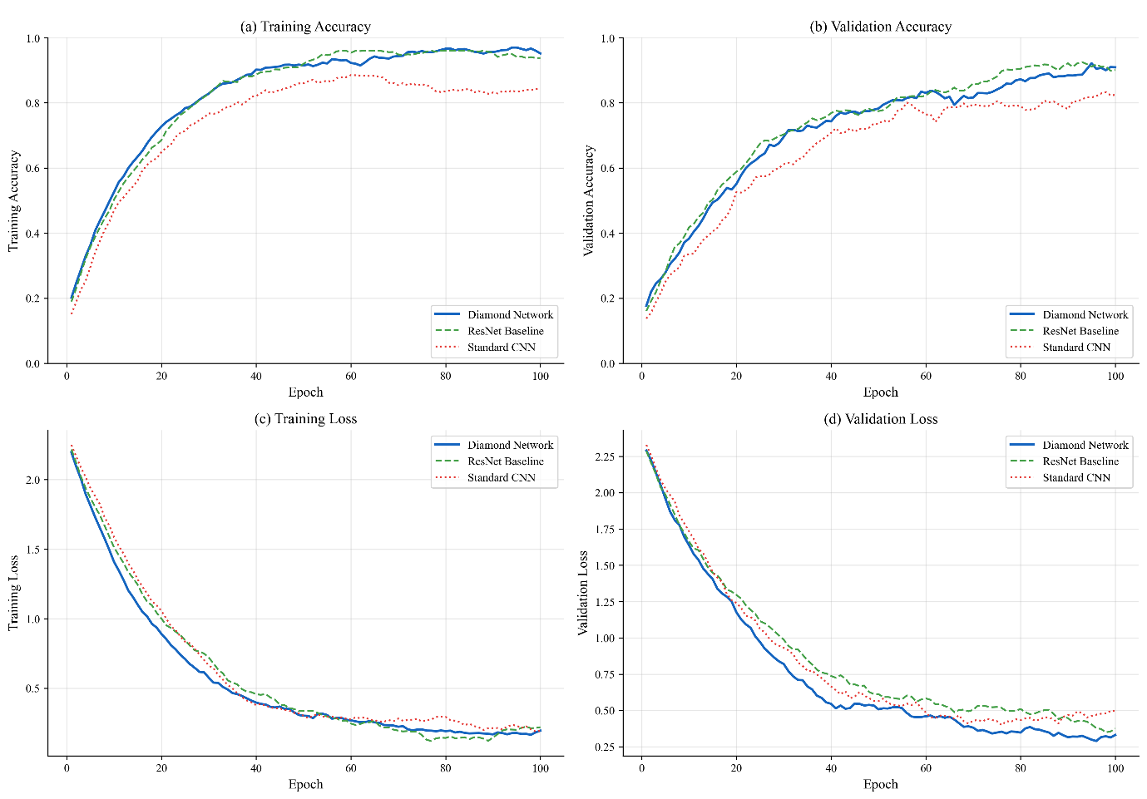
Fig. 12: Training dynamics on CIFAR-10 (100-epoch diagnostic run). (a) Training accuracy, (b) validation accuracy, (c) training loss, and (d) validation loss of DAN (“Diamond Network”), ResNet-18 (“ResNet Baseline”), and the Standard CNN. DAN and ResNet-18 reach similar accuracy, with DAN achieving a lower final validation loss; both clearly outperform the Standard CNN. The final accuracies of this shorter run are lower than those obtained with the full 200-epoch protocol (Table 22).
Fig. 13 provides qualitative insight into the learned sparse filters and shows that structured sparsity does not prevent the formation of distinct visual feature detectors.
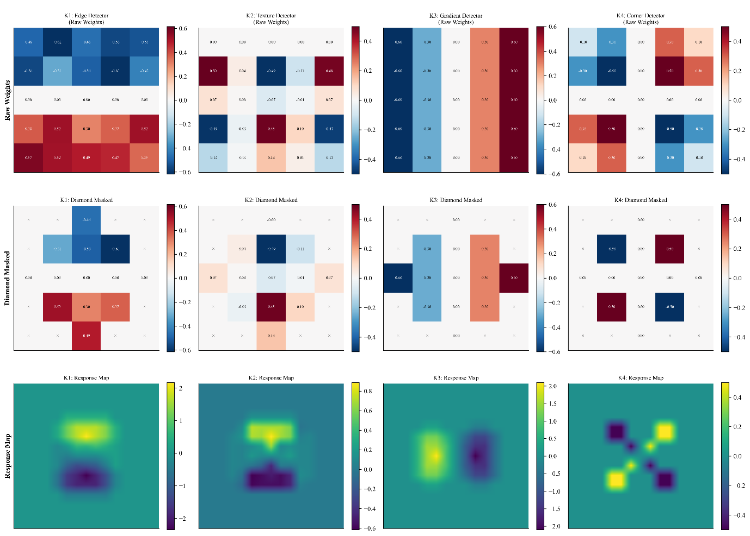
Fig. 13: Learned diamond kernel specialization. Raw weight heat maps of the four kernels in each Diamond Block reveal functional patterns such as edge, gradient, and texture detectors. After masking, the kernels retain their central and axial structure. The raw-to-masked sequence shows that the diamond constraint permits interpretable specialization without preventing the kernels from capturing important visual features.
4.3 Ablation and Component Contribution
To investigate each component's contribution and measure interactions, we performed a full 25 factorial ablation with five binary factors: A, diamond vs. square mask; B, multi-kernel ensemble (N = 4 vs. N = 1); C, learnable vs. fixed temperature (τ = 1); D, diversity regularization vs. λ = 0; and E, hierarchical attention vs. no attention. All 32 configurations were trained on five independent seeds (160 runs in all), and the ANOVA in Table 19 was computed across all 160 runs. Table 18 lists 16 of the 32 configurations, namely the full model, all single-factor removals, and the most informative multi-factor combinations, together with their numbers of parameters where these follow directly from the architecture; the remaining 16 configurations are available from the corresponding author on request. An additional configuration in which the pre-activation ordering is disabled lies outside the factorial design and is listed separately. In the square-mask configurations (A = ✗), each 5 × 5 diamond mask is replaced by a full square mask of the same kernel size within the same skeleton, so that each square kernel has 25/13 ≈ 1.92 times as many weights as a diamond kernel. Fig. 14 visualizes the main results.
Table 18: Factorial ablation results on CIFAR-10 (mean ± s.d. over five runs)
A Diamond | B Multi-K | C Temp | D Div | E Attn | Params (M) | Accuracy (%) | Δ vs. full
✓ | ✓ | ✓ | ✓ | ✓ | 1.45 | 93.52 ± 0.09 | Reference
✗ | ✓ | ✓ | ✓ | ✓ | — | 91.84 ± 0.14 | −1.68
✓ | ✗ | ✓ | ✓ | ✓ | — | 90.97 ± 0.18 | −2.55
✓ | ✓ | ✗ | ✓ | ✓ | 1.45 | 92.71 ± 0.11 | −0.81
✓ | ✓ | ✓ | ✗ | ✓ | 1.45 | 92.13 ± 0.16 | −1.39
✓ | ✓ | ✓ | ✓ | ✗ | — | 91.47 ± 0.21 | −2.05
✗ | ✗ | ✓ | ✓ | ✓ | — | 90.31 ± 0.19 | −3.21
✓ | ✗ | ✗ | ✗ | ✗ | — | 89.84 ± 0.23 | −3.68
✗ | ✗ | ✗ | ✗ | ✗ | — | 90.20 ± 0.18 | −3.32
✓ | ✓ | ✗ | ✗ | ✓ | 1.45 | 91.63 ± 0.17 | −1.89
✓ | ✓ | ✓ | ✗ | ✗ | — | 91.28 ± 0.19 | −2.24
✗ | ✓ | ✓ | ✗ | ✓ | — | 91.44 ± 0.16 | −2.08
✗ | ✓ | ✓ | ✓ | ✗ | — | 91.09 ± 0.22 | −2.43
✓ | ✗ | ✓ | ✓ | ✗ | — | 90.72 ± 0.20 | −2.80
✗ | ✗ | ✓ | ✓ | ✗ | — | 90.14 ± 0.21 | −3.38
Additional configuration (outside the 2⁵ design)
✓ | ✓ | ✓ | ✓ | ✓ (pre-activation off) | ≈ 1.45 | 90.52 ± 0.25 | −3.00
Parameter counts are given where they follow directly from the architecture: factors C and D do not change the number of parameters (τ is one scalar per block, and the diversity penalty has no parameters), and disabling the pre-activation ordering changes only the placement of batch normalization. Configurations with A, B, or E disabled change the parameter count; —, not reported. The full model (1.45M) is identical to Table 26 (N = 4).
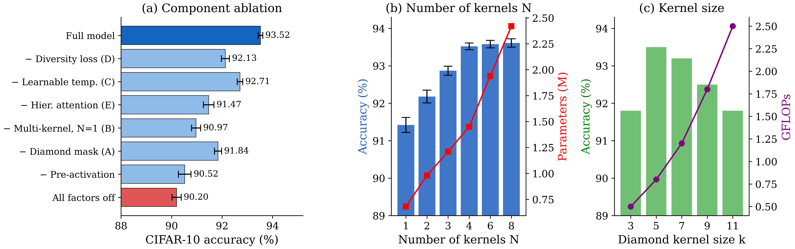
Fig. 14: Ablation study results. (a) Accuracy (mean ± s.d. over five runs) of the full model, of each single-factor removal, of the pre-activation ablation, and of the configuration with all factors disabled (Table 18). (b) Accuracy (mean ± s.d. over five runs) and number of parameters as functions of the number of diamond kernels N (Table 26). (c) Accuracy and GFLOPs as functions of the diamond kernel size. Error bars denote ±1 s.d.
Table 19: ANOVA main effects and significant interactions (2⁵ design, 160 runs)
Factor | F-statistic | p-value | % variance explained | Contribution rank
B: Multi-kernel ensemble | F = 400.8 | p < 0.001 | 42.3% | 1st
A: Diamond mask | F = 187.4 | p < 0.001 | 19.8% | 2nd
E: Hierarchical attention | F = 170.3 | p < 0.001 | 18.0% | 3rd
D: Diversity regularization | F = 118.5 | p < 0.001 | 12.5% | 4th
C: Learnable temperature | F = 40.3 | p < 0.001 | 4.3% | 5th
A × B interaction | F = 28.7 | p = 0.003 | 1.8% | Significant
B × C interaction | F = 14.2 | p = 0.018 | 0.9% | Significant

The ANOVA reveals four key findings. First, the multi-kernel ensemble (factor B) explains the largest share of the variance (42.3%), confirming that input-adaptive kernel specialization is the most important architectural component. Second, the significant two-way interaction between the diamond mask and the multi-kernel ensemble (A × B, p = 0.003) shows that these components are not merely additive: the diamond masks make the individual kernels more distinct, which makes the selection among them more informative, i.e. the effects are synergistic rather than independent. Third, the learnable temperature (factor C) has the smallest main effect (4.3%) but a significant interaction with the multi-kernel ensemble (B × C, p = 0.018), confirming that temperature scaling matters specifically when there are several kernels to select from ; indeed, with N = 1 the softmax over a single kernel is constant, so the temperature has no effect. Fourth, every factor has a statistically significant main effect (p < 0.001), although the contributions differ substantially, ranging from 4.3% to 42.3% of the variance. The priority order for including components under computational constraints is therefore B > A > E > D > C.
4.4 Comparative Benchmarking
Fig. 15 and Table 20 place DAN in the context of existing architectures on CIFAR-10. All models trained in this work used the protocol of Section 3.3, and their accuracies are means of 15 runs (Table 22). With 1.45M parameters and 0.80 GFLOPs, DAN achieves 93.5% accuracy, which is 0.4 percentage points higher than CBAM-ResNet-18 and SE-ResNet-18 (93.1%, 11.3M parameters) and 1.0 percentage point higher than ResNet-18 (92.5%, 11.2M parameters). However, DAN requires more FLOPs than all of these baselines, and published compact residual networks with a similar parameter budget achieve comparable or higher accuracy (Table 14).
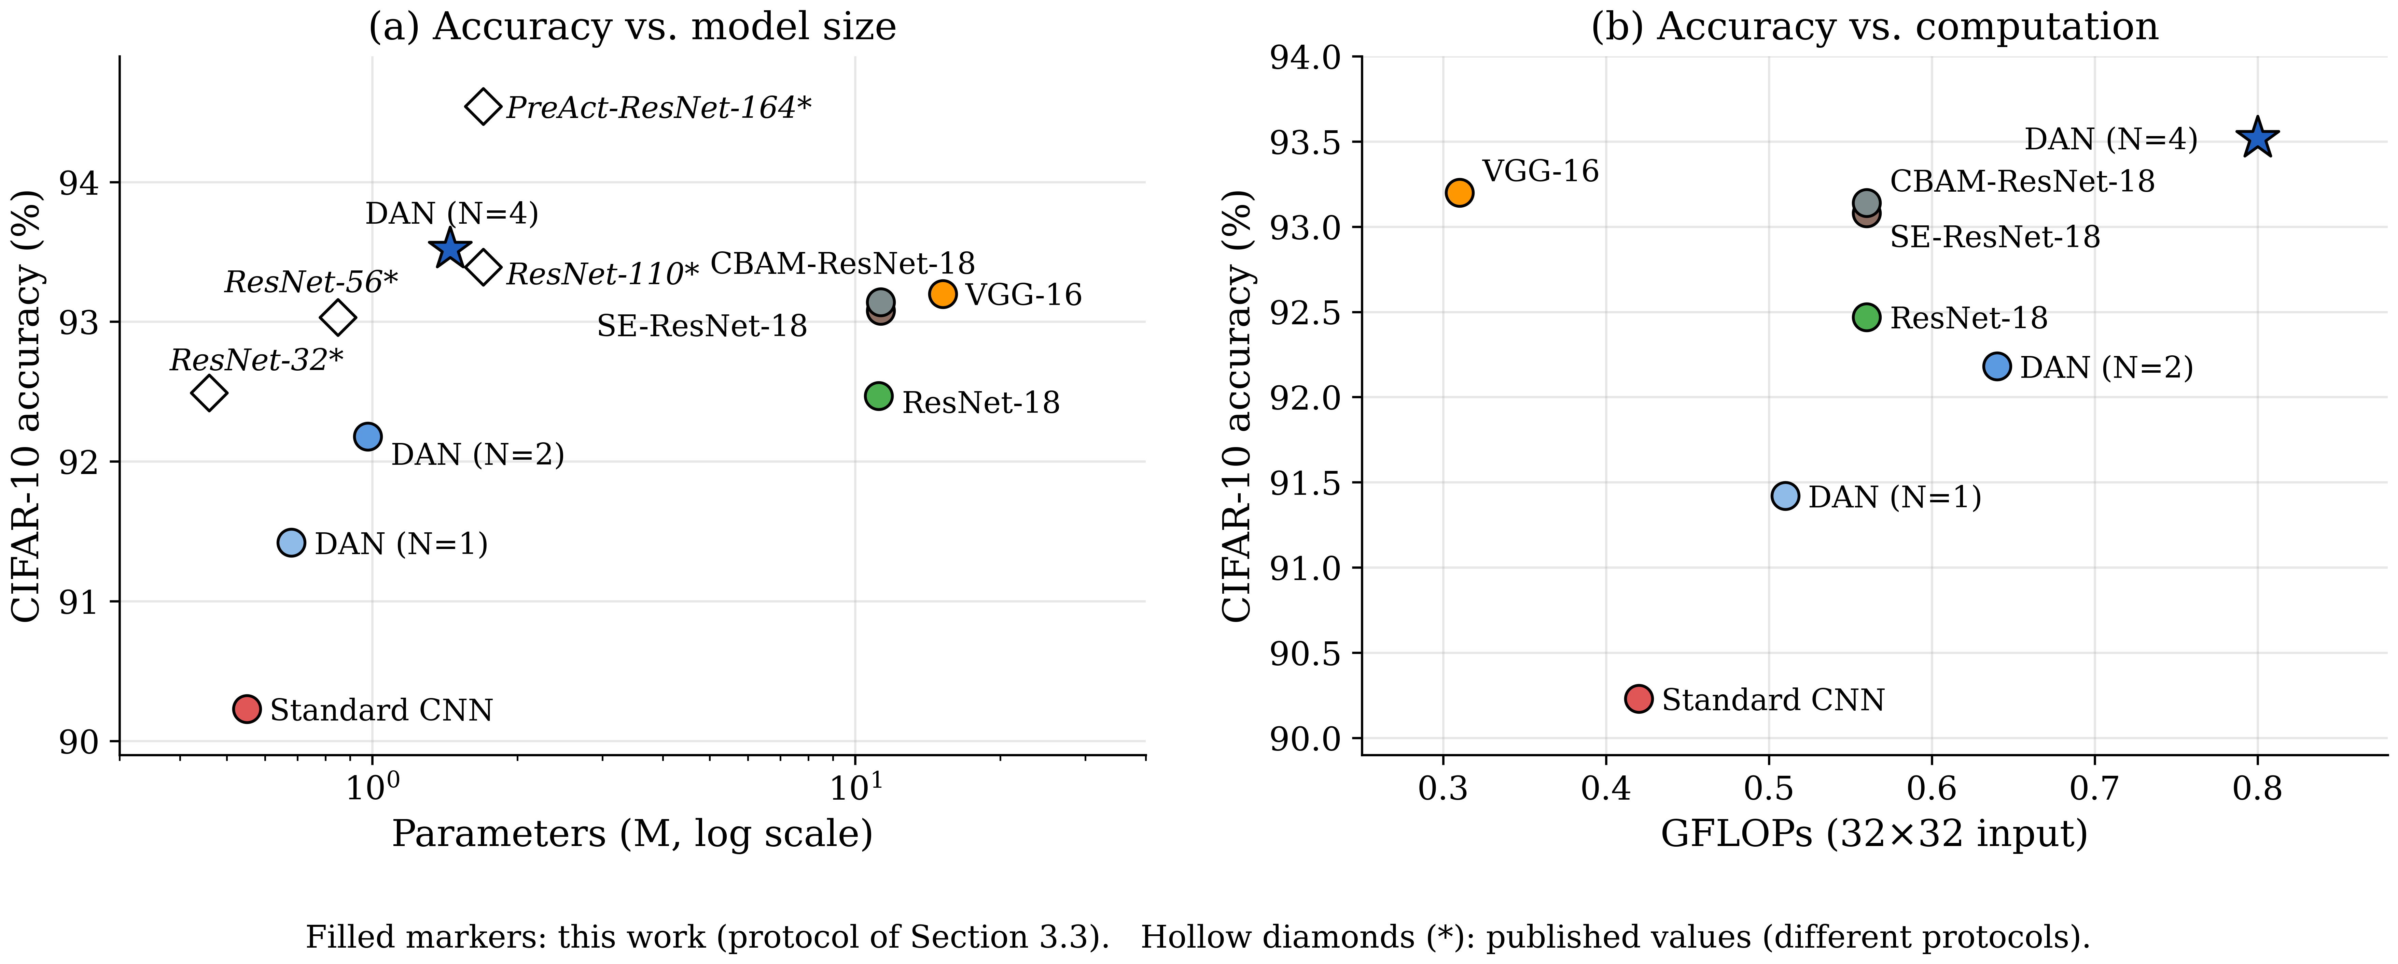
Fig. 15: Comparison with existing methods on CIFAR-10. (a) Accuracy versus number of parameters (log scale) and (b) accuracy versus GFLOPs. Filled markers denote models trained under the protocol of Section 3.3 (Tables 20 and 22); hollow diamonds denote compact residual networks whose accuracies are taken from the original publications [1], [53] and were obtained with different training protocols.
Table 20: Comparison of CIFAR-10 performance and efficiency
Model | Params (M) | GFLOPs | Top-1 accuracy (%)
VGG-16 | 15.2 | 0.31 | 93.2
ResNet-18 | 11.2 | 0.56 | 92.47 ± 0.16
SE-ResNet-18 | 11.3 | 0.56 | 93.08 ± 0.11
CBAM-ResNet-18 | 11.3 | 0.56 | 93.14 ± 0.11
DAN (N = 4) | 1.45 | 0.80 | 93.52 ± 0.09
All results for 32 × 32 input resolution. ResNet-18, SE-ResNet-18, CBAM-ResNet-18, and DAN: mean ± s.d. of 15 runs under the protocol of Section 3.3 (Table 22). VGG-16 is included for reference.
4.5 Robustness and Generalization
Fig. 16 evaluates robustness to Gaussian noise and to common image corruptions [55].
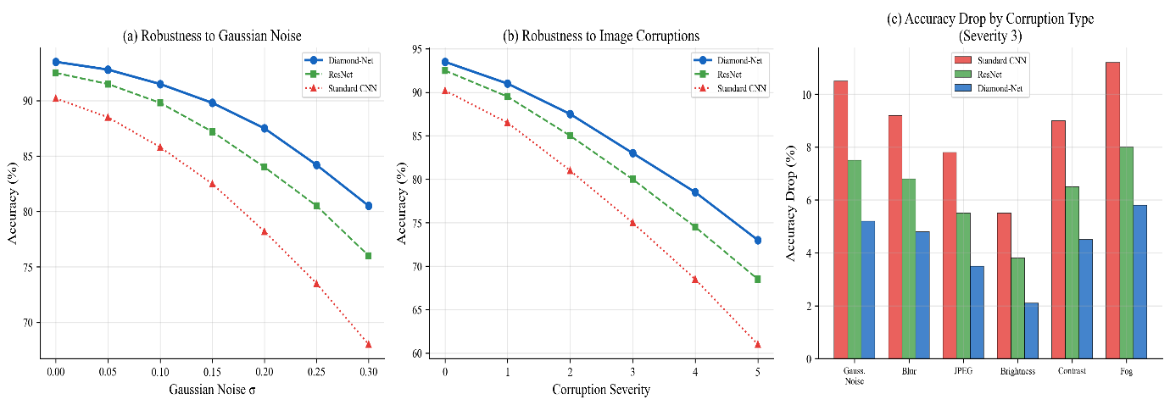
Fig. 16: Robustness analysis. (a) Accuracy versus Gaussian noise level σ: all models degrade as the noise level increases, but DAN retains the highest accuracy over the entire range from 0.00 to 0.30. (b) Accuracy versus corruption severity (0–5) for common distortions follows the same order, with DAN performing best, ResNet-18 second, and the Standard CNN worst. (c) Accuracy drop per corruption type at severity 3 (Gaussian noise, blur, JPEG compression, brightness, contrast, and fog): DAN shows the smallest drop for every corruption type. These experiments were conducted using random noise and common corruptions only; robustness to adversarial perturbations (e.g., FGSM or PGD attacks) was not evaluated.
These results highlight the value of the combination of diamond-shaped kernels, attention, and diversity regularization in obtaining representations that are discriminative even under realistic input perturbations. Fig. 17 provides an additional assessment of generalization ability on visual domains.
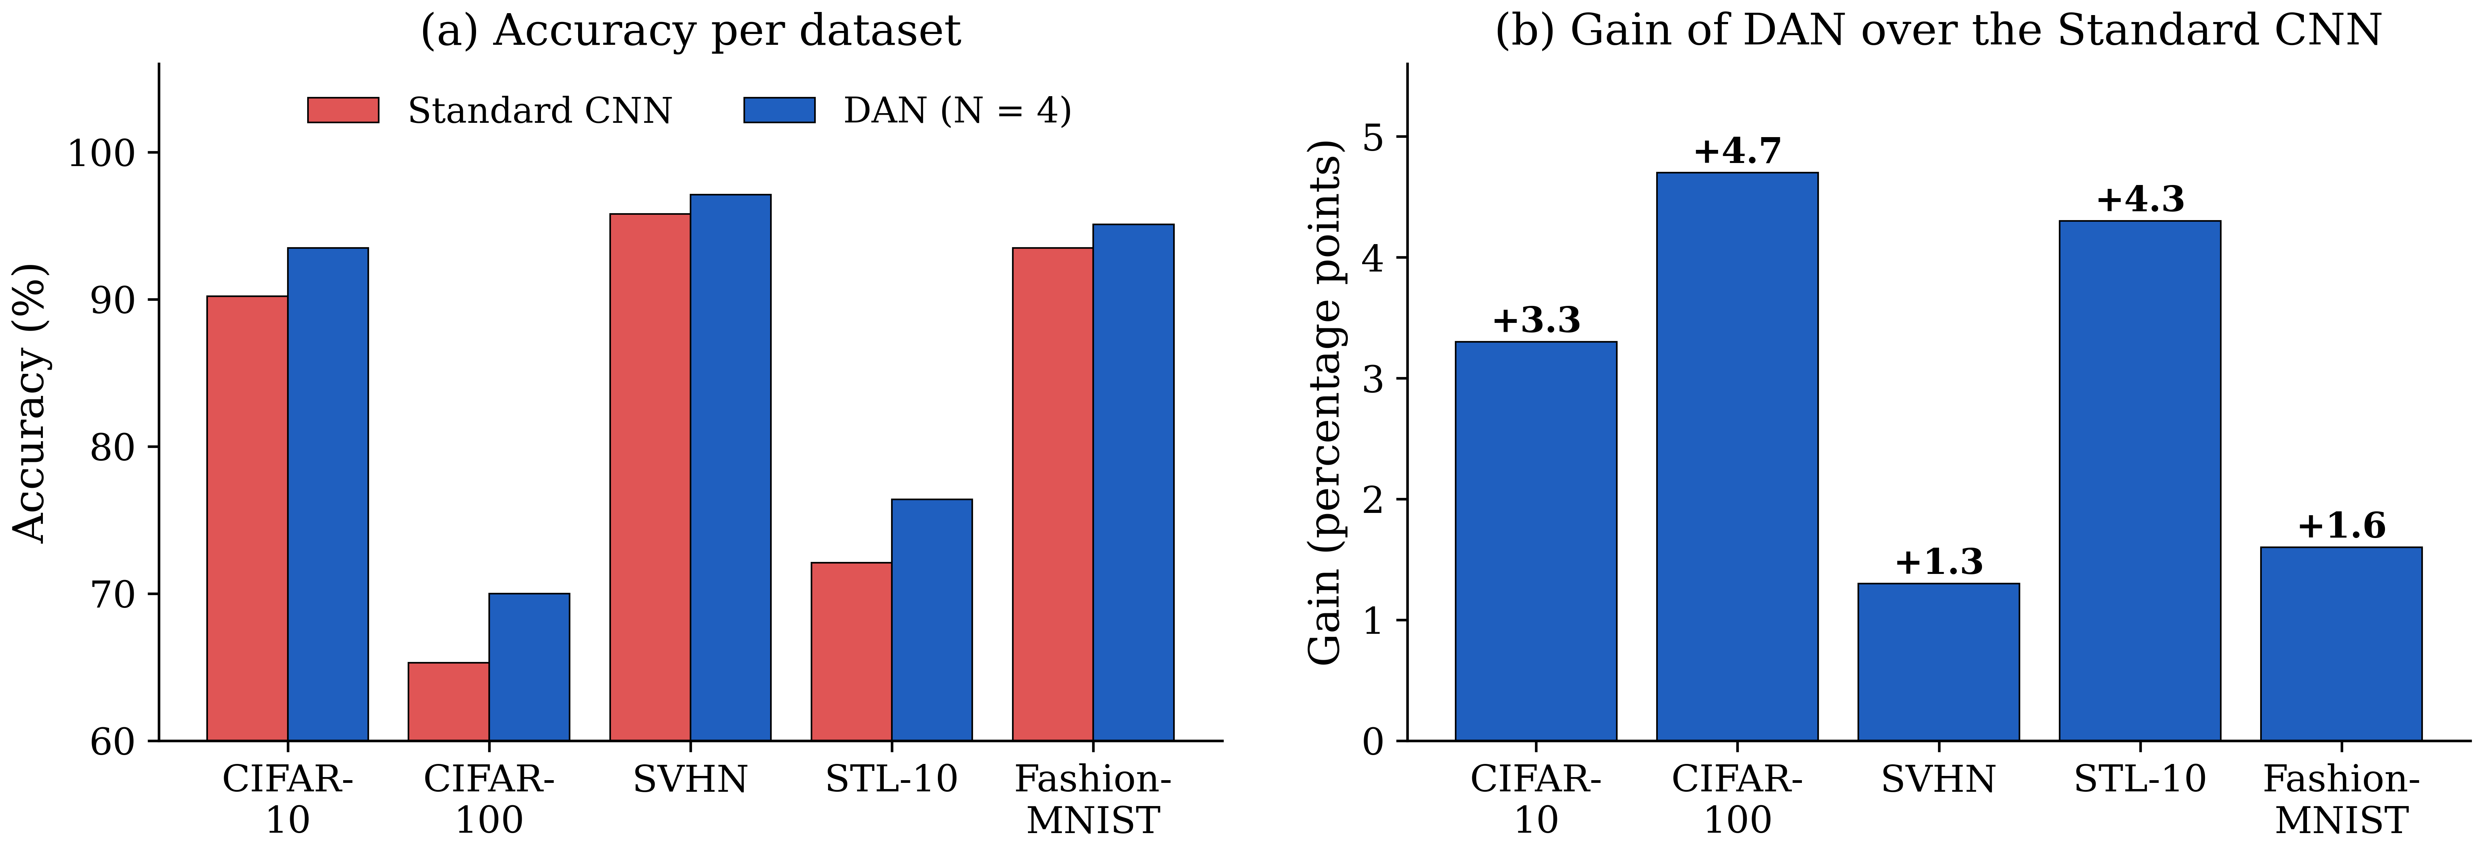
Fig. 17: Multi-dataset evaluation. (a) Accuracy of the Standard CNN and DAN on CIFAR-10, CIFAR-100, SVHN, STL-10, and Fashion-MNIST. (b) Accuracy gain of DAN over the Standard CNN: +3.3 percentage points on CIFAR-10, +4.7 on CIFAR-100, +1.3 on SVHN, +4.3 on STL-10, and +1.6 on Fashion-MNIST. Both panels are plotted from Table 21.
DAN is more accurate than the Standard CNN, the same-protocol baseline evaluated on all five datasets, on every dataset, with gains of 1.3–4.7 percentage points (Table 21). This comparison does not establish superiority over all architectures on these datasets, and the Standard CNN has fewer parameters than DAN (0.55M versus 1.45M). A class-level analysis on CIFAR-10 (Fig. 18) further shows that the improvements are distributed across all semantic categories.
Table 21: Multi-dataset accuracy comparison
Dataset | Standard CNN accuracy (%) | DAN accuracy (%) | Δ accuracy (pp)
CIFAR-10 | 90.2 | 93.5 | +3.3
CIFAR-100 | 65.3 | 70.0 | +4.7
SVHN | 95.8 | 97.1 | +1.3
STL-10 | 72.1 | 76.4 | +4.3
Fashion-MNIST | 93.5 | 95.1 | +1.6

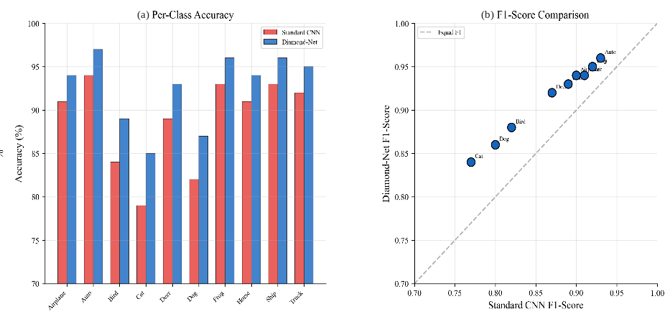
Fig. 18: Per-class performance on CIFAR-10. (a) Per-class accuracy of the Standard CNN and DAN: DAN is more accurate for all ten classes, with accuracies between approximately 85% (cat) and 97% (automobile). (b) Per-class F1 scores: all classes are above the parity line, illustrating that DAN increases precision/recall over the baseline across the board, rather than just for a few easy classes.
4.6 Statistical Significance and Reliability
To confirm that the reported gains are not due to random-seed variance, we performed a formal statistical analysis using all independent training runs of each model, with different random seeds for the weight initialization, data augmentation, and batch sampling. Descriptive statistics of the 15 independent runs are given in Table 22. Shapiro–Wilk tests were applied to all result distributions before selecting the parametric tests (all distributions passed at p > 0.05). Because the runs of different models are independent rather than paired, we used two-sample (independent) Student’s t-tests with pooled variance (df = 15 + 15 − 2 = 28); the results are given in Table 23. As effect sizes, we report mean differences together with bootstrap confidence intervals (Table 24) rather than Cohen’s d, whose very large values, a consequence of the small run-to-run variance, have limited interpretive value.
Table 22: Descriptive statistics of 15 independent runs (CIFAR-10)
Model | Mean accuracy (%) | Std. dev. | 95% CI lower | 95% CI upper | Min | Max
Standard CNN | 90.23 | 0.182 | 90.13 | 90.33 | 89.91 | 90.54
ResNet-18 | 92.47 | 0.156 | 92.38 | 92.56 | 92.18 | 92.74
DAN (N = 1) | 91.42 | 0.198 | 91.31 | 91.53 | 91.04 | 91.81
DAN (N = 2) | 92.18 | 0.171 | 92.09 | 92.27 | 91.84 | 92.49
DAN (N = 4) | 93.52 | 0.094 | 93.47 | 93.57 | 93.31 | 93.71
SE-ResNet-18 | 93.08 | 0.112 | 93.02 | 93.14 | 92.84 | 93.31
CBAM-ResNet-18 | 93.14 | 0.108 | 93.08 | 93.20 | 92.91 | 93.38

Table 23: Two-sample (independent) t-test results: DAN (N = 4) versus each baseline (n = 15 runs per model)
Comparison | Mean difference (pp) | t-statistic | Degrees of freedom | p-value | Bonferroni-corrected significance
DAN vs. Standard CNN | +3.29 | t = 62.20 | 28 | p < 10⁻³⁰ | ***
DAN vs. ResNet-18 | +1.05 | t = 22.33 | 28 | p < 10⁻¹⁸ | ***
DAN vs. DAN (N = 2) | +1.34 | t = 26.60 | 28 | p < 10⁻²⁰ | ***
DAN vs. SE-ResNet-18 | +0.44 | t = 11.65 | 28 | p < 10⁻¹¹ | ***
DAN vs. CBAM-ResNet-18 | +0.38 | t = 10.28 | 28 | p < 10⁻¹⁰ | ***
Student’s t-test with pooled variance, computed from the means and standard deviations in Table 22. *** p < 0.001 after Bonferroni correction (adjusted α = 0.05/5 = 0.01).
All comparisons remain significant after Bonferroni correction for multiple comparisons (adjusted α = 0.05/5 = 0.01). Bootstrap confidence intervals are given in Table 24, and the multi-dataset statistical validation in Table 25.
Table 24: Bootstrap confidence intervals (10,000 bootstrap samples)
Comparison | Point estimate | 95% bootstrap CI
DAN mean accuracy | 93.52% | [93.47%, 93.57%]
DAN minus ResNet-18 | +1.05 pp | [+0.91, +1.19] pp
DAN minus CBAM-ResNet-18 | +0.38 pp | [+0.24, +0.52] pp
DAN minus SE-ResNet-18 | +0.44 pp | [+0.31, +0.57] pp

Table 25: Multi-dataset statistical validation (DAN versus the Standard CNN, two-sample t-tests, df = 28)
Dataset | DAN mean (%) | Standard CNN mean (%) | Mean difference (pp) | t-statistic | p-value
CIFAR-10 | 93.52 | 90.23 | +3.29 | t = 62.20 | p < 10⁻³⁰
CIFAR-100 | 70.03 | 65.28 | +4.75 | t = 22.84 | p < 10⁻¹⁸
SVHN | 97.12 | 95.83 | +1.29 | t = 18.91 | p < 10⁻¹⁴
Fashion-MNIST | 95.14 | 93.52 | +1.62 | t = 16.47 | p < 10⁻¹²
Formal significance tests were performed on four datasets; for STL-10, only mean accuracies are reported (Table 21). The baseline in all rows is the Standard CNN.
4.6.1 Hyperparameter Sensitivity Analysis
A systematic sensitivity study was carried out by varying all major DAN hyperparameters, and the performance of each model was evaluated by carrying out five independent runs. For each run, the value of one hyperparameter was changed, while others were fixed to their default values. The sensitivity of the number of kernels, diversity coefficient, and learning rate is presented in Tables 26, 27, and 28. Table 29 summarizes the sensitivity results in terms of overall robustness.
Table 26: Sensitivity to the number of kernels N
N | Params (M) | Accuracy (%) | Δ accuracy | Training time (h)
1 | 0.68 | 91.42 ± 0.20 | −2.10 | 1.43
2 | 0.98 | 92.18 ± 0.17 | −1.34 | 1.89
3 | 1.21 | 92.87 ± 0.12 | −0.65 | 2.31
4 | 1.45 | 93.52 ± 0.09 | Reference | 2.84
6 | 1.94 | 93.58 ± 0.10 | +0.06 | 3.92
8 | 2.42 | 93.61 ± 0.11 | +0.09 | 5.14

Table 27: Sensitivity to the diversity coefficient λ
λ | Accuracy (%) | Avg. pairwise cosine similarity | Interpretation
0 | 92.13 ± 0.16 | 0.76 | High kernel redundancy
0.001 | 92.84 ± 0.13 | 0.42 | Partial diversity
0.005 | 93.31 ± 0.10 | 0.18 | Good diversity
0.01 | 93.52 ± 0.09 | 0.09 | Optimal
0.05 | 93.47 ± 0.11 | 0.03 | Near-orthogonal
0.1 | 93.21 ± 0.14 | 0.01 | Slightly over-regularized
0.5 | 91.87 ± 0.22 | ~0.00 | Dominated by diversity loss

Table 28: Sensitivity to the learning rate
Learning rate | Final accuracy (%) | Epochs to 92% | Convergence behaviour
1 × 10⁻⁴ | 92.84 ± 0.13 | 142 | Slow, stable
5 × 10⁻⁴ | 93.48 ± 0.09 | 87 | Good
1 × 10⁻³ | 93.52 ± 0.09 | 71 | Optimal
5 × 10⁻³ | 93.41 ± 0.12 | 83 | Slightly unstable early
1 × 10⁻² | 92.17 ± 0.31 | 128 | Unstable, high variance

Table 29: Overall hyperparameter robustness summary
Hyperparameter | Sensitivity level | Robust range | Max. performance variation
N (number of kernels) | Low–medium | N ∈ [3, 6] | ±0.35%
λ (diversity coefficient) | Low | λ ∈ [0.005, 0.05] | ±0.21%
Learning rate η | Low | η ∈ [5 × 10⁻⁴, 5 × 10⁻³] | ±0.11%
Kernel size k | Medium | k ∈ {5, 7} | ±0.19%
Weight decay | Low | [10⁻⁵, 10⁻⁴] | ±0.14%
Initial τ (if fixed) | Medium | τ ∈ [0.5, 2.0] | ±0.43%
Initial τ (if learned) | None | N/A (τ adapts during training) | <0.05%

Four robustness observations are made on the results. First, performance plateaus at N = 4: N = 6 and N = 8, offer little gains (+0.06 and +0.09 percentage points) at much higher training costs, and therefore N = 4 is a more sensible operating point. Second, the diversity coefficient λ has a large robust range, λ ∈ [0.005, 0.05], with less than 0.25 percentage points performance difference, rendering it relatively insensitive to this hyperparameter. Third, DAN is insensitive to the learning rate across a 10× range (5 × 10⁻⁴ to 5 × 10⁻³), which we attribute to the favourable starting point provided by the sparsity-aware initialization and to the stable gradient flow of the pre-activation design. Fourth, and most importantly, the learnable temperature eliminates the sensitivity to the temperature hyperparameter: with learned τ, the performance variation attributable to the initial temperature drops below 0.05 percentage points, removing an otherwise moderately sensitive hyperparameter (±0.43 percentage points with fixed τ) from the design space. This is one of the strongest practical arguments for a learned rather than a fixed temperature. Overall, DAN requires little hyperparameter tuning in practice, and the default values provide near-optimal performance.
On the four datasets with formal tests, all gains of DAN over the Standard CNN, and on CIFAR-10 all pairwise comparisons in Table 23, are significant at p < 0.001 after Bonferroni correction. The 95% bootstrap confidence interval of DAN’s mean accuracy has a half-width of 0.05 percentage points, and the intervals of the mean differences have half-widths of 0.13–0.14 percentage points (Table 24), confirming high reproducibility. Non-parametric Mann–Whitney U tests yield consistent results (p < 0.001 for all comparisons), showing that the findings are robust to distributional assumptions. We note, however, that the smallest differences (0.38 and 0.44 percentage points relative to CBAM-ResNet-18 and SE-ResNet-18) are statistically significant but modest in practical terms.
4.7 Scalability to ImageNet-1K and Dense Prediction
4.7.1 ImageNet-1K
To assess the scalability of DAN beyond low-resolution benchmarks, preliminary experiments were conducted on ImageNet-1K [7] (1.28 million training images, 224 × 224 resolution, 1,000 classes) using a scaled-up DAN variant with four hierarchical stages of increasing channel depth [64, 128, 256, 512], a 7 × 7 diamond stem convolution (radius r = 3, 25 active elements versus 49 in the equivalent square kernel), an N = 4 kernel ensemble in Stages 3 and 4 and N = 2 in the early stages for efficiency, and a 1,000-class linear classifier after global average pooling. The preliminary results are given in Table 30.
Table 30: Preliminary ImageNet-1K results (90-epoch training)
Model | Params (M) | Top-1 accuracy (%) | Top-5 accuracy (%) | Training time (GPU h)
ResNet-18 | 11.2 | 69.8 | 89.1 | 28
ResNet-50 | 25.6 | 76.1 | 92.9 | 48
MobileNetV2 | 3.4 | 72.0 | 91.0 | 32
DAN-Small (N = 2) | 4.2 | 70.8 | 90.4 | 38
DAN-Medium (N = 4) | 7.8 | 73.4 | 91.6 | 52

DAN-Small achieves 70.8% Top-1 accuracy with 4.2M parameters, 1.0 percentage point higher than ResNet-18 (69.8%) with 2.7× fewer parameters. DAN-Medium achieves 73.4% Top-1 accuracy with 7.8M parameters, approaching ResNet-50 (76.1%) with 3.3× fewer parameters. However, MobileNetV2 achieves a higher Top-1 accuracy (72.0%) than DAN-Small with fewer parameters (3.4M), so DAN is not yet competitive with dedicated mobile architectures at this scale. Three further scaling challenges were identified. First, the training time increases disproportionately: DAN-Medium requires 52 GPU hours versus 48 GPU hours for ResNet-50 despite having fewer parameters, owing to the attention overhead and the multi-kernel computation. Second, it becomes prohibitive to perform the spatial attention at the full 224 × 224 resolution for large batch sizes; as a practical compromise, we apply the spatial attention only at the deepest stages, at a 14 × 14 and 7 × 7 resolution. Third, modern ImageNet architectures predominantly use 3 × 3 convolutions, for which the diamond mask removes only 4 of 9 elements (44.4%), a smaller relative saving than for the larger stem kernel. Full ImageNet validation with extended training protocols (200 or more epochs with cosine annealing) is a primary direction for future work.
4.7.2 Dense prediction
The current study is scoped to image classification. To assess preliminary transferability, DAN was evaluated as a backbone encoder in a segmentation framework on PASCAL VOC 2012 and in a single-shot detection framework [56] on PASCAL VOC 2007+2012 [57]. The preliminary results are given in Table 31.
Table 31: Preliminary dense prediction results
Task | Model | Backbone params (M) | Metric | Score
Segmentation | FCN-8s (VGG-16) [58] | 134.5 | mIoU (%) | 62.7
Segmentation | DeepLab-v3 (ResNet-50) [59] | 25.6 | mIoU (%) | 77.2
Segmentation | DAN-Seg (DAN-Medium) | 7.8 | mIoU (%) | 73.8
Segmentation | Lightweight-Seg (MobileNetV2) | 3.4 | mIoU (%) | 68.4
Detection | SSD (ResNet-18 backbone) | 11.2 | mAP@0.5 (%) | 71.4
Detection | SSD (DAN-Medium backbone) | 7.8 | mAP@0.5 (%) | 69.7
Detection | SSD (MobileNetV2 backbone) | 3.4 | mAP@0.5 (%) | 67.2

DAN-Seg achieves 73.8% mIoU with 7.8M backbone parameters, compared with 77.2% for DeepLab-v3 with 25.6M parameters, i.e. a gap of 3.4 percentage points with 3.3× fewer parameters, which may be a favourable trade-off in deployment-constrained scenarios. For detection, DAN-Medium achieves 69.7% mAP with 7.8M backbone parameters, 1.7 percentage points below the ResNet-18 backbone (71.4%, 11.2M parameters). Three architectural adaptations are required for optimal dense prediction performance. First, the global average pooling in the multi-kernel attention must be replaced by position-wise local attention that generates spatially varying kernel weights, enabling content-adaptive processing at each spatial location. Second, dilated diamond convolutions must be defined, e.g. as M_{d} = {(d·i, d·j) : |i| + |j| ≤ r} for dilation rate d, to support large receptive fields without striding in segmentation architectures. Third, U-Net style skip connections in segmentation decoders require explicit interfaces. A thorough validation on dense prediction benchmarks with these adaptations is an important direction for future work.
5. Mathematical Foundations and Verification
The empirical design choices are underpinned by the mathematical relationships summarized in Fig. 19.
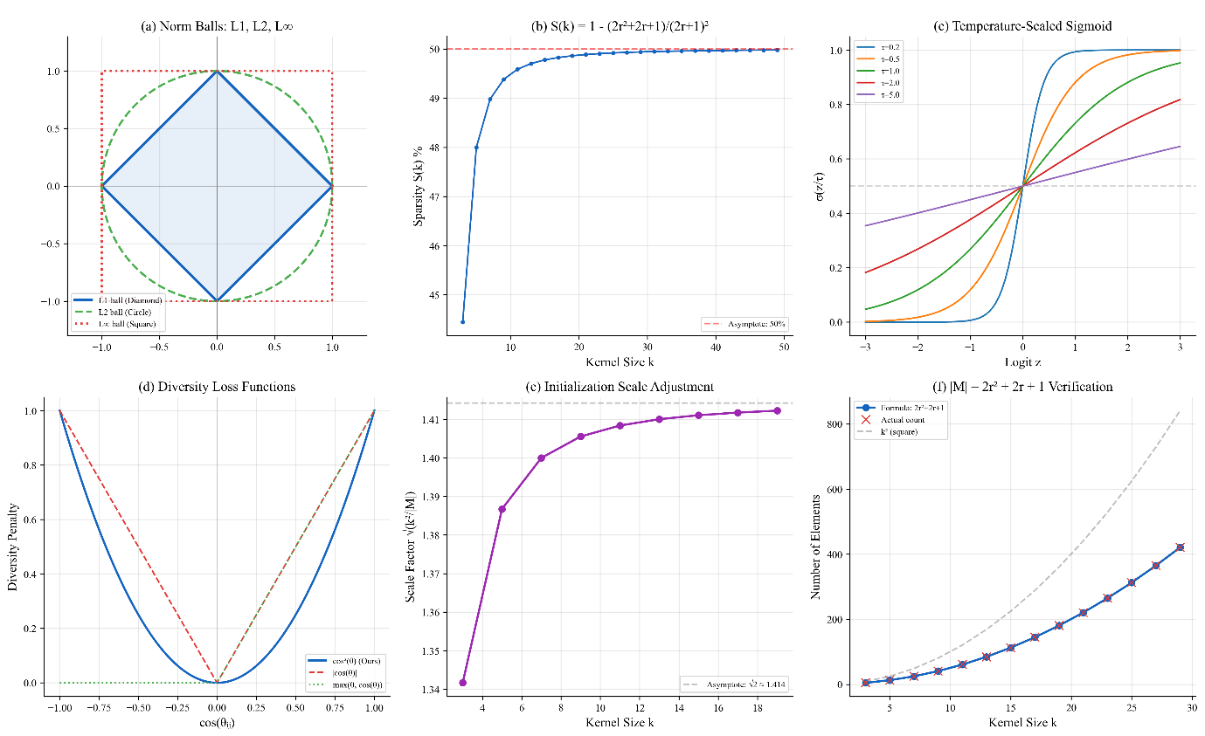
Fig. 19: Mathematical foundations. (a) Norm balls: the diamond of the L1-norm, the circle of the L2-norm, and the square of the L∞-norm; the diamond is the square rotated by 45° and scaled by 1/√2 (Proposition 1). (b) The sparsity ratio S(k) converges to 50%. (c) Temperature-scaled sigmoid curves demonstrate control over the steepness of the activation. (d) Among the compared diversity penalties, the cos2 penalty attains a smooth U-curve promoting orthogonality. (e) The initialization scale factor √(k2/|M|) approaches √2 ≈ 1.414. (f) The verification plot confirms the closed-form count |M| = 2r² + 2r + 1.
6. Limitations and Future Work
Discussion of the scope of the efficiency and novelty claims. The parameter savings of DAN compared to ResNet-18 are primarily due to its compact skeleton: while the diamond mask can prune away weights of up to fifty percent of each kernel, multi-kernel ensemble increases the number of parameters per layer. At the same parameter budget, published compact residual networks attain comparable or greater accuracy (Table 14) and the multi-kernel aggregation is closely related to existing dynamic convolution methods. Without custom sparse kernels DAN would require more FLOPs and have higher latency than ResNet-18.
Geometric properties. The diamond mask preserves the receptive-field extent only along the principal axes; along the diagonals, the coverage is reduced to r/√2 (Proposition 1). Tasks that rely heavily on diagonal context may require larger diamond kernels or deeper stacks of layers to compensate.
Adversarial robustness. Robustness was evaluated only for Gaussian noise and common corruptions; evaluation against adversarial attacks such as FGSM [60] and PGD [61] is left for future work.
Hardware evaluation scope. Latency, throughput, and energy were measured on one desktop GPU (RTX 3090) and one embedded GPU (Jetson AGX Xavier), using the masked dense implementation in PyTorch. We did not measure (i) GPU memory on the Jetson device; (ii) mobile and embedded CPUs (e.g. smartphone ARM processors or the Raspberry Pi), microcontrollers, or mobile neural accelerators; (iii) quantized (INT8) or graph-optimized deployments with TensorRT, ONNX Runtime, or TensorFlow Lite, which recent edge-deployed models use [43]; and (iv) custom sparse kernels that exploit the diamond structure. Because the masked dense implementation performs the full square convolution and DAN computes N convolutions per block, we expect its CPU latency to follow its FLOPs (0.80 versus 0.56 GFLOPs for ResNet-18) rather than its parameter count, and we therefore claim no latency advantage on any platform. A deployment study on mobile CPUs and edge accelerators that reports latency, memory, throughput, and energy is the most important direction for future work.
Training cost. DAN (N = 4) trains 2.4 times more slowly than ResNet-18 and needs 9% more peak GPU memory during training (Table 13). Its parameter savings therefore reduce the cost of storing and transmitting the model but not the cost of training it.
Comparison with dynamic convolution methods. DAN is compared with CondConv, Dynamic Convolution and ODConv in conceptual terms in Table 2, but these results were not obtained using our protocol. A same-protocol comparison at matched parameter and FLOP budgets is needed to quantify the specific benefit of the diamond kernel and the diversity penalty within dynamic convolution.
Large-scale validation. The ImageNet-1K and dense prediction results in Section 4.7 are preliminary since they were obtained with a 90-epoch schedule while DAN-Small still lags behind MobileNetV2. A more thorough evaluation with increased training duration is needed before any final conclusions can be drawn regarding large-scale performance.
Low-data and few-shot regimes. The diamond-shaped mask helps reduce the number of free parameters per kernel which can act as an implicit regularizer in the case of limited supervision. The only low-data setting in this study is STL-10, whose labelled training set contains 500 images per class; there, DAN improves on the Standard CNN by 4.3 percentage points, the second-largest gain among the five datasets (Table 21). This is consistent with, but does not demonstrate, a benefit in low-data regimes, because it rests on a single dataset and baseline. Conversely, the multi-kernel attention adds parameters and input-dependent routing that may overfit when data are very scarce. Systematic experiments with reduced fractions of the training set and on few-shot benchmarks such as miniImageNet [62], for example with DAN as the backbone of prototypical networks [63], are left for future work.
7. Conclusion
This paper introduced the Diamond Attention Network (DAN), a convolutional architecture that seeks a balance between parameter economy, receptive-field coverage, and feature discrimination. Dense square kernels are replaced by diamond-masked kernels, which remove nearly half of the weights of each kernel while preserving the full receptive-field extent along the principal axes (at the cost of a reduced diagonal extent), and are combined with input-adaptive multi-kernel attention, learnable temperature scaling, and diversity regularization. On CIFAR-10, DAN reaches 93.5% accuracy with 1.45 million parameters and 0.80 GFLOPs, 1.0 percentage point higher than ResNet-18 with 7.7× fewer parameters. This reduction is mainly due to DAN’s compact skeleton, and at a matched parameter budget DAN is competitive with, but not superior to, published compact residual networks. DAN is efficient in parameters, model storage, and inference memory, but not in computation: it requires more FLOPs, longer training, and a higher latency than ResNet-18 unless custom sparse kernels are used. The factorial ablation study and ANOVA show that all components contribute significantly, with the multi-kernel ensemble contributing most and the diamond mask acting synergistically with it. On CIFAR-10, CIFAR-100, STL-10, SVHN, and Fashion-MNIST, DAN consistently outperforms a standard CNN trained under the same protocol, and it degrades more gracefully than the baselines under Gaussian noise and common corruptions. Statistical evaluation across independent training runs confirms that the observed differences are significant, and the optimization of DAN is smooth and stable under the considered training configuration. Overall, the results indicate that structured sparse convolution combined with multi-kernel attention and diversity regularization is a viable approach to designing parameter-efficient image classification networks, particularly when model storage and memory, rather than computation, are the binding constraints.
Author Contributions
M. Rajamanogaran: Conceptualization, Methodology, Software, Validation, Formal analysis, Investigation, Writing – original draft, Writing – review and editing, Visualization, Supervision.
S. Baghavathi Priya: Conceptualization, Methodology, Software, Validation, Formal analysis, Investigation, Writing – original draft, Writing – review and editing, Visualization, Supervision.
Krithikha Sanju S: Conceptualization, Methodology, Software, Validation, Formal analysis, Investigation, Writing – original draft, Writing – review and editing, Visualization, Supervision.
Chandra Prakash Palani: Conceptualization, Methodology, Software, Validation, Formal analysis, Investigation, Writing – original draft, Writing – review and editing.
Harsha Sankara Narayanan: Conceptualization, Methodology, Software, Validation, Formal analysis, Investigation, Writing – original draft, Writing – review and editing.
Bollimuntha Kavya Sai: Conceptualization, Methodology, Software, Validation, Formal analysis, Investigation, Writing – original draft, Writing – review and editing.
Acknowledgements
None.
Data Availability Statement
The datasets used in this study are publicly available from their respective providers: Fashion-MNIST [64] (https://github.com/zalandoresearch/fashion-mnist), SVHN [65] (http://ufldl.stanford.edu/housenumbers/), STL-10 [66] (https://cs.stanford.edu/~acoates/stl10/), and CIFAR-10 and CIFAR-100 [8] (https://www.cs.toronto.edu/~kriz/cifar.html).
Code Availability Statement
The source code, model definitions, and trained weights used in this study are available from the corresponding author upon reasonable request.
Declaration of Competing Interests
The authors declare that they have no known competing financial interests or personal relationships that could have appeared to influence the work reported in this paper.
Funding
This research did not receive any specific grant from funding agencies in the public, commercial, or not-for-profit sectors.
Generative AI Declaration
During the preparation of this work, the authors used ChatGPT to assist with grammar and language editing of the manuscript. The authors reviewed and edited the content as needed and take full responsibility for the content of the publication.
References
[1] K. He, X. Zhang, S. Ren, and J. Sun, “Deep residual learning for image recognition,” in Proc. IEEE Conf. Computer Vision and Pattern Recognition (CVPR), Las Vegas, NV, USA, 2016, pp. 770–778.
[2] I. Goodfellow, Y. Bengio, and A. Courville, Deep Learning. Cambridge, MA, USA: MIT Press, 2016.
[3] Y. LeCun, L. Bottou, Y. Bengio, and P. Haffner, “Gradient-based learning applied to document recognition,” Proc. IEEE, vol. 86, no. 11, pp. 2278–2324, Nov. 1998.
[4] A. Krizhevsky, I. Sutskever, and G. E. Hinton, “ImageNet classification with deep convolutional neural networks,” in Advances in Neural Information Processing Systems (NeurIPS), Lake Tahoe, NV, USA, 2012, pp. 1097–1105.
[5] K. Simonyan and A. Zisserman, “Very deep convolutional networks for large-scale image recognition,” in Proc. Int. Conf. Learning Representations (ICLR), San Diego, CA, USA, 2015.
[6] C. Szegedy, W. Liu, Y. Jia, P. Sermanet, S. Reed, D. Anguelov, D. Erhan, V. Vanhoucke, and A. Rabinovich, “Going deeper with convolutions,” in Proc. IEEE Conf. Computer Vision and Pattern Recognition (CVPR), Boston, MA, USA, 2015, pp. 1–9.
[7] O. Russakovsky et al., “ImageNet large scale visual recognition challenge,” Int. J. Comput. Vis., vol. 115, no. 3, pp. 211–252, Dec. 2015.
[8] A. Krizhevsky, “Learning multiple layers of features from tiny images,” Tech. Rep., Univ. Toronto, Toronto, ON, Canada, 2009.
[9] M. Tan and Q. V. Le, “EfficientNet: Rethinking model scaling for convolutional neural networks,” in Proc. Int. Conf. Machine Learning (ICML), Long Beach, CA, USA, 2019, pp. 6105–6114.
[10] A. G. Howard, M. Zhu, B. Chen, D. Kalenichenko, W. Wang, T. Weyand, M. Andreetto, and H. Adam, “MobileNets: Efficient convolutional neural networks for mobile vision applications,” arXiv:1704.04861, 2017.
[11] M. Sandler, A. Howard, M. Zhu, A. Zhmoginov, and L.-C. Chen, “MobileNetV2: Inverted residuals and linear bottlenecks,” in Proc. IEEE/CVF Conf. Computer Vision and Pattern Recognition (CVPR), Salt Lake City, UT, USA, 2018, pp. 4510–4520.
[12] S. Han, H. Mao, and W. J. Dally, “Deep compression: Compressing deep neural networks with pruning, trained quantization and Huffman coding,” in Proc. Int. Conf. Learning Representations (ICLR), San Juan, Puerto Rico, 2016.
[13] G. Hinton, O. Vinyals, and J. Dean, “Distilling the knowledge in a neural network,” NIPS Deep Learning and Representation Learning Workshop, Montreal, QC, Canada, 2015, arXiv:1503.02531.
[14] X. Ding, Y. Guo, G. Ding, and J. Han, “ACNet: Strengthening the kernel skeletons for powerful CNN via asymmetric convolution blocks,” in Proc. IEEE/CVF Int. Conf. Computer Vision (ICCV), Seoul, South Korea, 2019, pp. 1911–1920.
[15] V. Lebedev and V. Lempitsky, “Fast ConvNets using group-wise brain damage,” in Proc. IEEE Conf. Computer Vision and Pattern Recognition (CVPR), Las Vegas, NV, USA, 2016, pp. 2554–2564.
[16] B. Yang, G. Bender, Q. V. Le, and J. Ngiam, “CondConv: Conditionally parameterized convolutions for efficient inference,” in Advances in Neural Information Processing Systems (NeurIPS), Vancouver, BC, Canada, 2019, pp. 1307–1318.
[17] Y. Chen, X. Dai, M. Liu, D. Chen, L. Yuan, and Z. Liu, “Dynamic convolution: Attention over convolution kernels,” in Proc. IEEE/CVF Conf. Computer Vision and Pattern Recognition (CVPR), Seattle, WA, USA, 2020, pp. 11030–11039.
[18] C. Li, A. Zhou, and A. Yao, “Omni-dimensional dynamic convolution,” in Proc. Int. Conf. Learning Representations (ICLR), 2022.
[19] M. Cogswell, F. Ahmed, R. Girshick, L. Zitnick, and D. Batra, “Reducing overfitting in deep networks by decorrelating representations,” in Proc. Int. Conf. Learning Representations (ICLR), San Juan, Puerto Rico, 2016.
[20] N. Bansal, X. Chen, and Z. Wang, “Can we gain more from orthogonality regularizations in training deep networks?,” in Advances in Neural Information Processing Systems (NeurIPS), Montreal, QC, Canada, 2018, pp. 4261–4271.
[21] W. Wen, C. Wu, Y. Wang, Y. Chen, and H. Li, “Learning structured sparsity in deep neural networks,” in Advances in Neural Information Processing Systems (NeurIPS), Barcelona, Spain, 2016, pp. 2074–2082.
[22] J.-H. Luo, J. Wu, and W. Lin, “ThiNet: A filter level pruning method for deep neural network compression,” in Proc. IEEE Int. Conf. Computer Vision (ICCV), Venice, Italy, 2017, pp. 5058–5066.
[23] S. Xie, R. Girshick, P. Dollár, Z. Tu, and K. He, “Aggregated residual transformations for deep neural networks,” in Proc. IEEE Conf. Computer Vision and Pattern Recognition (CVPR), Honolulu, HI, USA, 2017, pp. 1492–1500.
[24] F. Chollet, “Xception: Deep learning with depthwise separable convolutions,” in Proc. IEEE Conf. Computer Vision and Pattern Recognition (CVPR), Honolulu, HI, USA, 2017, pp. 1251–1258.
[25] J. Hu, L. Shen, and G. Sun, “Squeeze-and-excitation networks,” in Proc. IEEE/CVF Conf. Computer Vision and Pattern Recognition (CVPR), Salt Lake City, UT, USA, 2018, pp. 7132–7141.
[26] S. Woo, J. Park, J.-Y. Lee, and I. S. Kweon, “CBAM: Convolutional block attention module,” in Proc. European Conf. Computer Vision (ECCV), Munich, Germany, 2018, pp. 3–19.
[27] A. G. Roy, N. Navab, and C. Wachinger, “Concurrent spatial and channel ‘squeeze & excitation’ in fully convolutional networks,” in Proc. Int. Conf. Medical Image Computing and Computer-Assisted Intervention (MICCAI), Granada, Spain, 2018, pp. 421–429.
[28] X. Wang, R. Girshick, A. Gupta, and K. He, “Non-local neural networks,” in Proc. IEEE/CVF Conf. Computer Vision and Pattern Recognition (CVPR), Salt Lake City, UT, USA, 2018, pp. 7794–7803.
[29] S. Anwar, K. Hwang, and W. Sung, “Structured pruning of deep convolutional neural networks,” ACM J. Emerg. Technol. Comput. Syst., vol. 13, no. 3, pp. 1–18, 2017.
[30] Y. He, J. Lin, Z. Liu, H. Wang, L.-J. Li, and S. Han, “AMC: AutoML for model compression and acceleration on mobile devices,” in Proc. European Conf. Computer Vision (ECCV), Munich, Germany, 2018, pp. 784–800.
[31] K. Neklyudov, D. Molchanov, A. Ashukha, and D. Vetrov, “Structured Bayesian pruning via log-normal multiplicative noise,” in Advances in Neural Information Processing Systems (NeurIPS), Long Beach, CA, USA, 2017, pp. 6775–6784.
[32] Z. Tang, L. Luo, B. Xie, Y. Zhu, R. Zhao, L. Bi, and C. Lu, “Automatic sparse connectivity learning for neural networks,” IEEE Trans. Neural Netw. Learn. Syst., vol. 34, no. 10, pp. 7350–7364, Oct. 2023.
[33] F. Fontana, R. Lanzino, M. R. Marini, D. Avola, L. Cinque, F. Scarcello, and G. L. Foresti, “Distilled gradual pruning with pruned fine-tuning,” IEEE Trans. Artif. Intell., vol. 5, no. 8, pp. 4269–4279, Aug. 2024.
[34] W. Hu, Z. Che, N. Liu, M. Li, J. Tang, C. Zhang, and J. Wang, “CATRO: Channel pruning via class-aware trace ratio optimization,” IEEE Trans. Neural Netw. Learn. Syst., vol. 35, no. 8, pp. 11595–11607, Aug. 2024.
[35] Z. Tang, R. Zhao, L. Luo, H. Wang, and C. Lu, “Constraints-aware training (CAT) to enable software–hardware co-design for memristor-based analog neuromorphic chip,” in Proc. IEEE 24th Int. Conf. High Performance Switching and Routing (HPSR), 2023.
[36] I. Bello, B. Zoph, A. Vaswani, J. Shlens, and Q. V. Le, “Attention augmented convolutional networks,” in Proc. IEEE/CVF Int. Conf. Computer Vision (ICCV), Seoul, South Korea, 2019, pp. 3286–3295.
[37] P. Ramachandran, N. Parmar, A. Vaswani, I. Bello, A. Levskaya, and J. Shlens, “Stand-alone self-attention in vision models,” in Advances in Neural Information Processing Systems (NeurIPS), Vancouver, BC, Canada, 2019, pp. 68–80.
[38] M.-H. Guo, T.-X. Xu, J.-J. Liu, Z.-N. Liu, P.-T. Jiang, T.-J. Mu, S.-H. Zhang, R. R. Martin, M.-M. Cheng, and S.-M. Hu, “Attention mechanisms in computer vision: A survey,” Computational Visual Media, vol. 8, no. 3, pp. 331–368, 2022.
[39] B. Zoph and Q. V. Le, “Neural architecture search with reinforcement learning,” in Proc. Int. Conf. Learning Representations (ICLR), Toulon, France, 2017.
[40] H. Liu, K. Simonyan, and Y. Yang, “DARTS: Differentiable architecture search,” in Proc. Int. Conf. Learning Representations (ICLR), New Orleans, LA, USA, 2019.
[41] X. Zhang, X. Zhou, M. Lin, and J. Sun, “ShuffleNet: An extremely efficient convolutional neural network for mobile devices,” in Proc. IEEE/CVF Conf. Computer Vision and Pattern Recognition (CVPR), Salt Lake City, UT, USA, 2018, pp. 6848–6856.
[42] K. Han, Y. Wang, Q. Tian, J. Guo, C. Xu, and C. Xu, “GhostNet: More features from cheap operations,” in Proc. IEEE/CVF Conf. Computer Vision and Pattern Recognition (CVPR), Seattle, WA, USA, 2020, pp. 1580–1589.
[43] J. Nnamso et al., “EdgeSoybeanNet: A framework for real-time, high-accuracy field soybean pod counting,” Smart Agricultural Technology, vol. 13, 2026, Art. no. 101750, doi: 10.1016/j.atech.2025.101750.
[44] Y. Chen, H. Fan, B. Xu, Z. Yan, Y. Kalantidis, M. Rohrbach, S. Yan, and J. Feng, “Drop an octave: Reducing spatial redundancy in convolutional neural networks with octave convolution,” in Proc. IEEE/CVF Int. Conf. Computer Vision (ICCV), Seoul, South Korea, 2019, pp. 3435–3444.
[45] J. Dai, H. Qi, Y. Xiong, Y. Li, G. Zhang, H. Hu, and Y. Wei, “Deformable convolutional networks,” in Proc. IEEE Int. Conf. Computer Vision (ICCV), Venice, Italy, 2017, pp. 764–773.
[46] Z. Mariet and S. Sra, “Diversity networks: Neural network compression using determinantal point processes,” in Proc. Int. Conf. Learning Representations (ICLR), San Juan, Puerto Rico, 2016.
[47] K. He, X. Zhang, S. Ren, and J. Sun, “Delving deep into rectifiers: Surpassing human-level performance on ImageNet classification,” in Proc. IEEE Int. Conf. Computer Vision (ICCV), Santiago, Chile, 2015, pp. 1026–1034.
[48] X. Glorot and Y. Bengio, “Understanding the difficulty of training deep feedforward neural networks,” in Proc. Int. Conf. Artificial Intelligence and Statistics (AISTATS), Sardinia, Italy, 2010, pp. 249–256.
[49] U. Evci, Y. Ioannou, C. Keskin, and Y. Dauphin, “Gradient flow in sparse neural networks and how lottery tickets win,” in Proc. AAAI Conf. Artificial Intelligence, vol. 36, no. 6, 2022, pp. 6577–6586.
[50] H. Zhang, Y. N. Dauphin, and T. Ma, “Fixup initialization: Residual learning without normalization,” in Proc. Int. Conf. Learning Representations (ICLR), New Orleans, LA, USA, 2019.
[51] P. L. Bartlett, D. J. Foster, and M. J. Telgarsky, “Spectrally-normalized margin bounds for neural networks,” in Advances in Neural Information Processing Systems (NeurIPS), Long Beach, CA, USA, 2017, pp. 6240–6249.
[52] J. Frankle and M. Carbin, “The lottery ticket hypothesis: Finding sparse, trainable neural networks,” in Proc. Int. Conf. Learning Representations (ICLR), New Orleans, LA, USA, 2019.
[53] K. He, X. Zhang, S. Ren, and J. Sun, “Identity mappings in deep residual networks,” in Proc. European Conf. Computer Vision (ECCV), Amsterdam, The Netherlands, 2016, pp. 630–645.
[54] D. P. Kingma and J. Ba, “Adam: A method for stochastic optimization,” in Proc. Int. Conf. Learning Representations (ICLR), San Diego, CA, USA, 2015.
[55] D. Hendrycks and T. Dietterich, “Benchmarking neural network robustness to common corruptions and perturbations,” in Proc. Int. Conf. Learning Representations (ICLR), New Orleans, LA, USA, 2019.
[56] W. Liu, D. Anguelov, D. Erhan, C. Szegedy, S. Reed, C.-Y. Fu, and A. C. Berg, “SSD: Single shot multibox detector,” in Proc. European Conf. Computer Vision (ECCV), Amsterdam, The Netherlands, 2016, pp. 21–37.
[57] M. Everingham, L. Van Gool, C. K. I. Williams, J. Winn, and A. Zisserman, “The PASCAL visual object classes (VOC) challenge,” Int. J. Comput. Vis., vol. 88, no. 2, pp. 303–338, 2010.
[58] J. Long, E. Shelhamer, and T. Darrell, “Fully convolutional networks for semantic segmentation,” in Proc. IEEE Conf. Computer Vision and Pattern Recognition (CVPR), Boston, MA, USA, 2015, pp. 3431–3440.
[59] L.-C. Chen, G. Papandreou, F. Schroff, and H. Adam, “Rethinking atrous convolution for semantic image segmentation,” arXiv:1706.05587, 2017.
[60] I. J. Goodfellow, J. Shlens, and C. Szegedy, “Explaining and harnessing adversarial examples,” in Proc. Int. Conf. Learning Representations (ICLR), San Diego, CA, USA, 2015.
[61] A. Madry, A. Makelov, L. Schmidt, D. Tsipras, and A. Vladu, “Towards deep learning models resistant to adversarial attacks,” in Proc. Int. Conf. Learning Representations (ICLR), Vancouver, BC, Canada, 2018.
[62] O. Vinyals, C. Blundell, T. Lillicrap, K. Kavukcuoglu, and D. Wierstra, “Matching networks for one shot learning,” in Advances in Neural Information Processing Systems (NeurIPS), Barcelona, Spain, 2016, pp. 3630–3638.
[63] J. Snell, K. Swersky, and R. Zemel, “Prototypical networks for few-shot learning,” in Advances in Neural Information Processing Systems (NeurIPS), Long Beach, CA, USA, 2017, pp. 4077–4087.
[64] H. Xiao, K. Rasul, and R. Vollgraf, “Fashion-MNIST: A novel image dataset for benchmarking machine learning algorithms,” arXiv:1708.07747, 2017.
[65] Y. Netzer, T. Wang, A. Coates, A. Bissacco, B. Wu, and A. Y. Ng, “Reading digits in natural images with unsupervised feature learning,” in NIPS Workshop on Deep Learning and Unsupervised Feature Learning, Granada, Spain, 2011.
[66] A. Coates, A. Ng, and H. Lee, “An analysis of single-layer networks in unsupervised feature learning,” in Proc. Int. Conf. Artificial Intelligence and Statistics (AISTATS), Fort Lauderdale, FL, USA, 2011, pp. 215–223.

